DIFFERENT METHODS OF PASSIVE INFORMATION GATHERING OF DIFFERENT WEBSITES:

**FOORPRINTING AND RECONNAISSANCE OF** [**WWW.INTELLIPAAT.COM**](http://www.intellipaat.com) **THROUGH SEARCH ENGINES AND ADVANCED GOOGLE SEARCH:**

**1.GENERAL GOOGLE RESEARCH:**

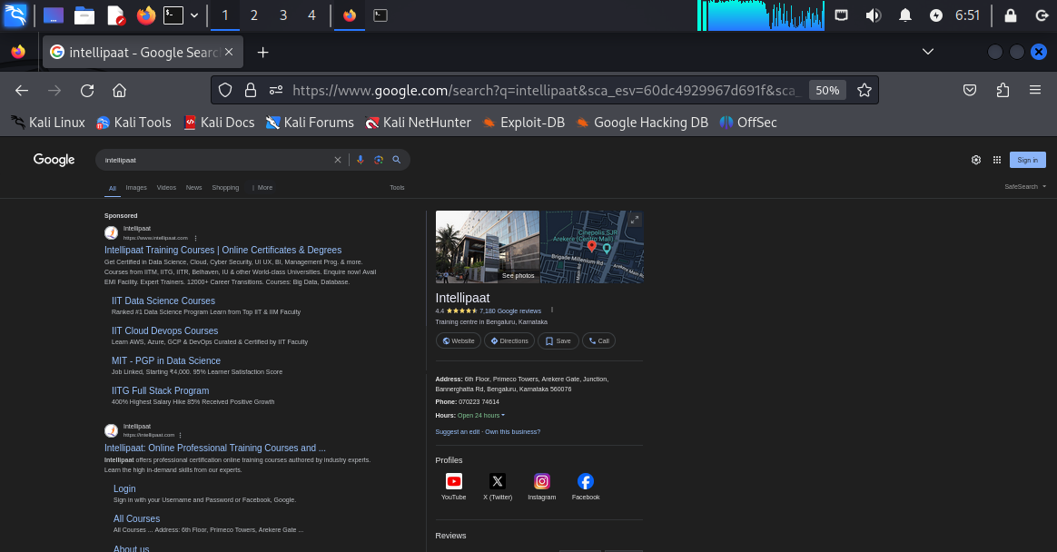

**As we can see that just by typing “intellipaat” on google we have got various websites open regarding intellipaat official website along with different courses and login links,about us tags.**

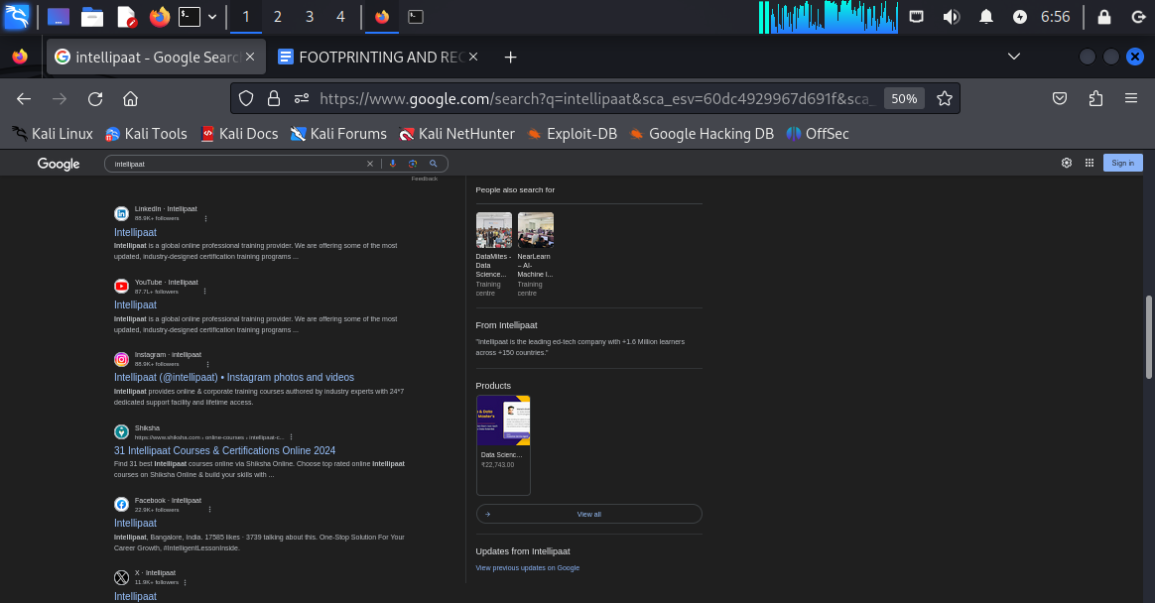

**Also in the second half of the screenshot we can see the webpage contains direct links towards “YOUTUBE VIDEOS”, “FACEBOOK PAGE” ,”INSTAGRAM PAGE”,”LINKEDIN PROFILE”,AND AT THE TOP RIGHT WE HAVE GOT “INTELLIPAAT OFFICE PHYSICAL ADDRESS” ALONG WITH A PICTURE OF THE INTELLIPAAT OFFICE WITH A DETAILED DESCRIPTION.**

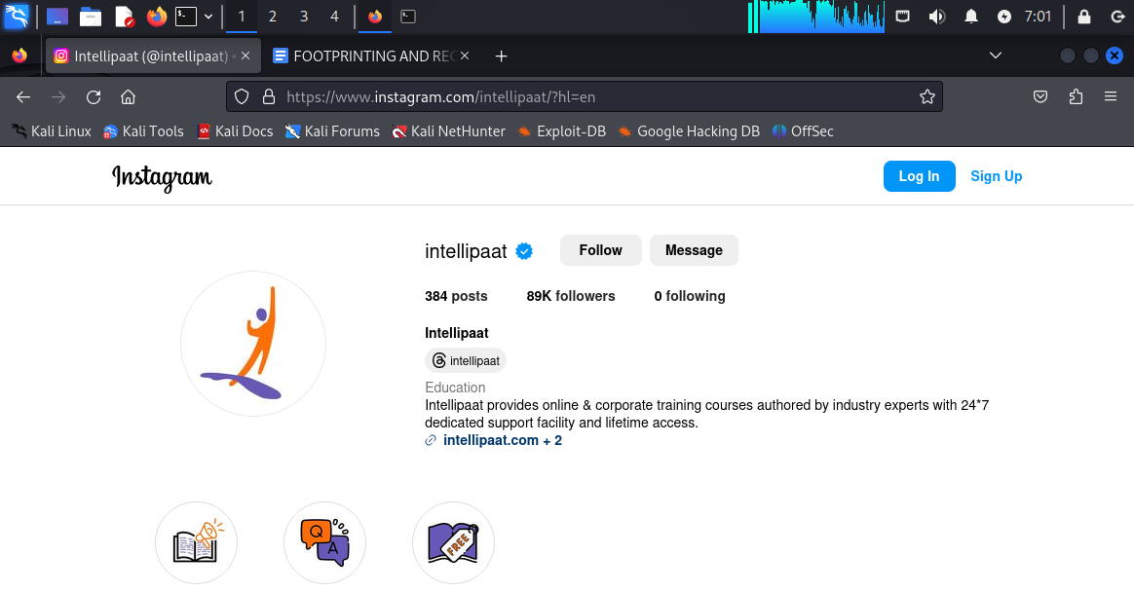

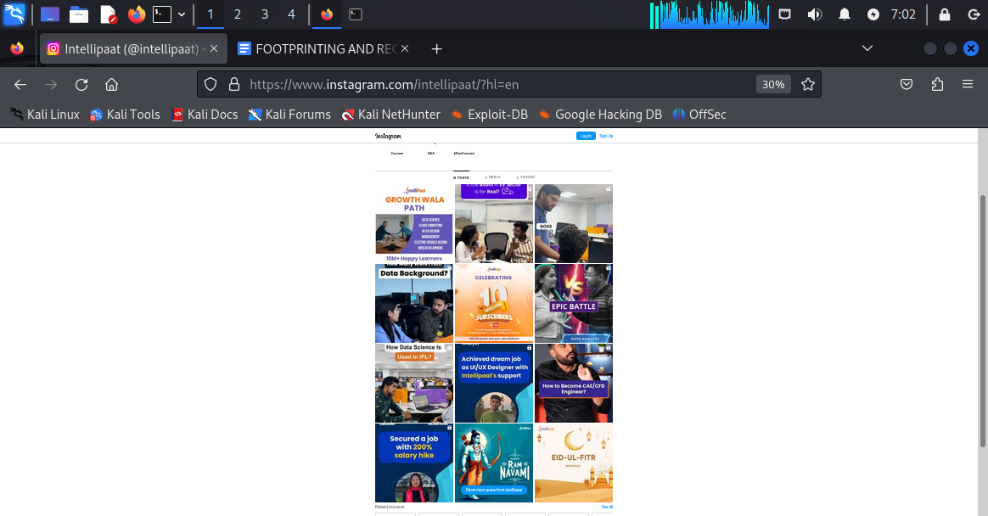

**This is the view of the instagram home page without logging into “instagram”**

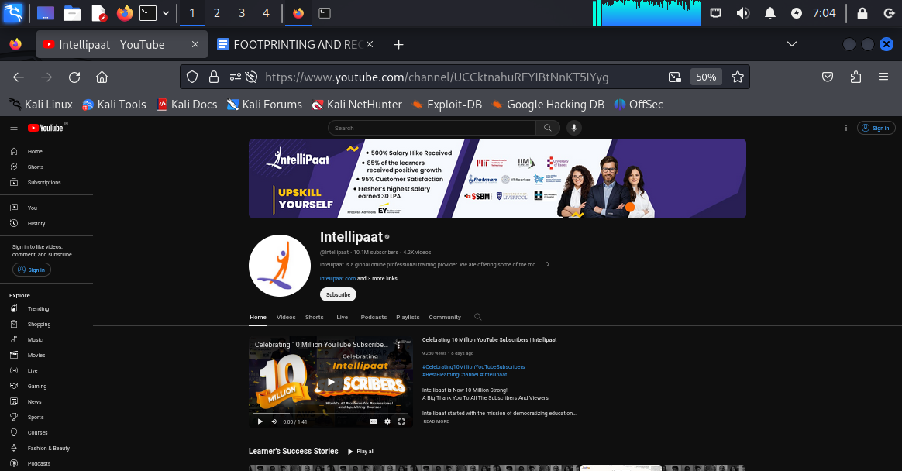

**Youtube channel homepage view with number of subscribers “10.1 M” and number of videos whioch is “4.2K”.**

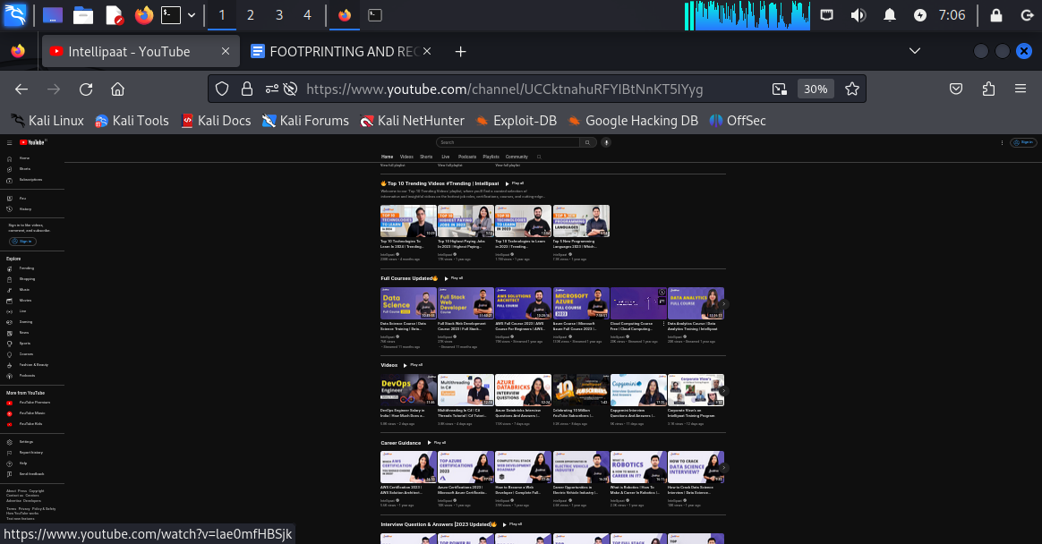

**SECOND SCREENSHOT OF YOUTUBE PAGE WHERE WE CAN SEE DIFFERENT SUB-SECTION LIKE “TOP 10 TRENDING VIDEOS” OR “FULL COURSES UPDATED” , “ CAREER GUIDANCE”**

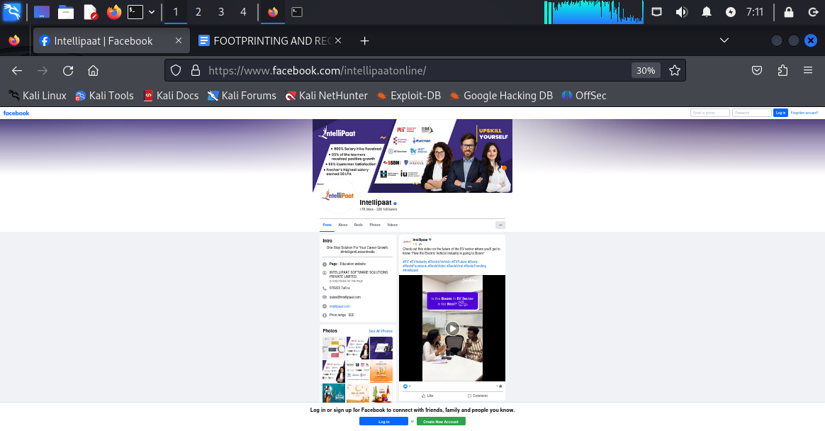

**FACEBOOK HOMEPAGE VIEW WITH INFORMATION SUCH AS “Address”,”phone number”,”website”,”collection of demo images and videos”.**

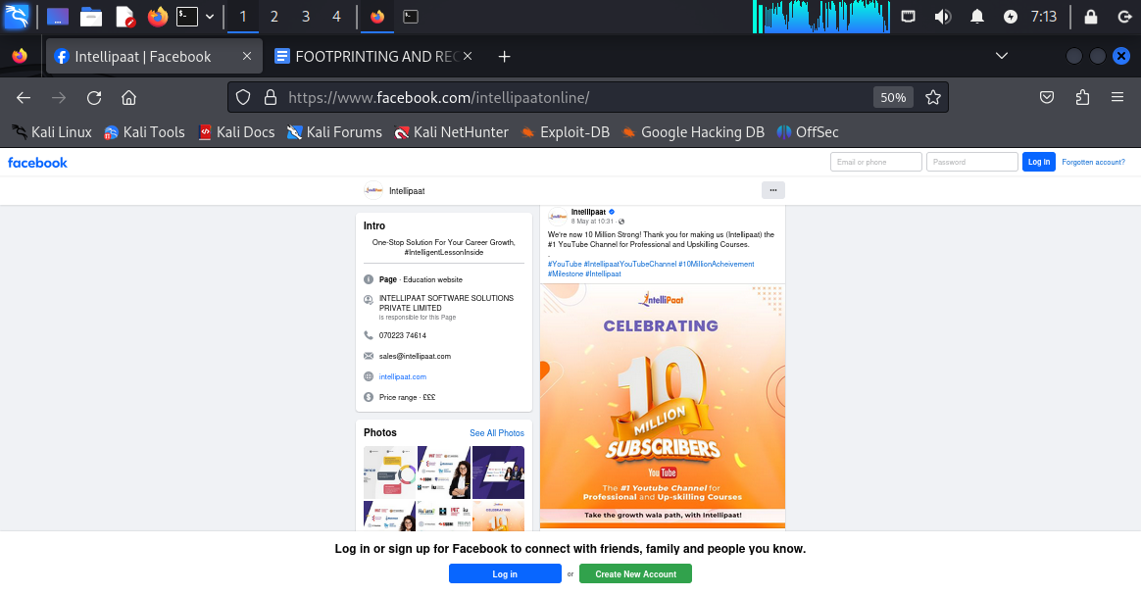

**Updates about latest achievements:**

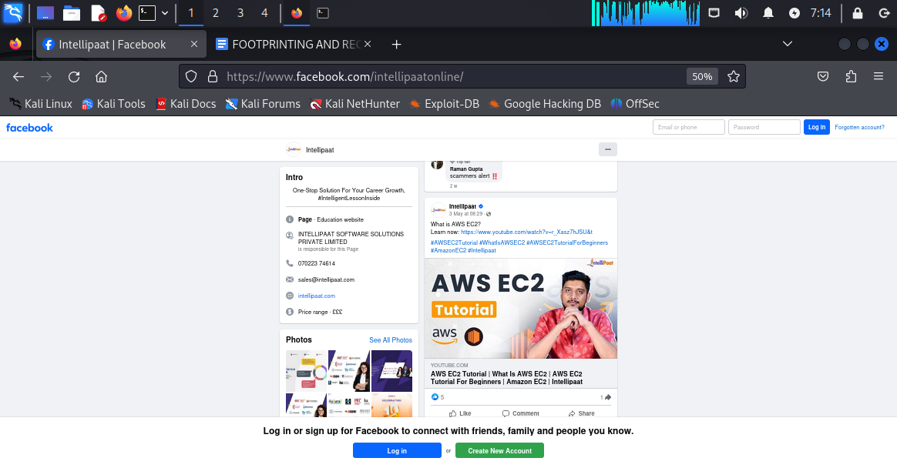

**Short videos and demonstration about latest trendy cloud service like AWS.**

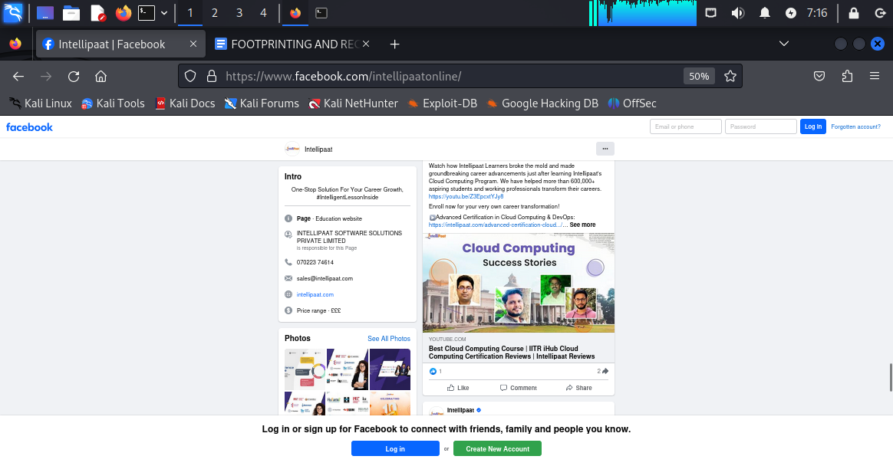

**SUCCESS STORIES AFTER PLACEMENT FROM INTELLIPAAT STUDENTS:**

**2.ADVANCED GOOGLE SEARCH:**

**1. site:intellipaat.com**

**2. related: intellipaat.com**

**3. Intitle: intellipaat**

**4. Allintitle: intellipaat careers**

**5. Inurl : intellipaat**

**6. Allinurl: intellipaat placement**

**7. Intext : intellipaat**

**8. Allintext : intellipaat courses**

**9 .cache: intellipaat.com**

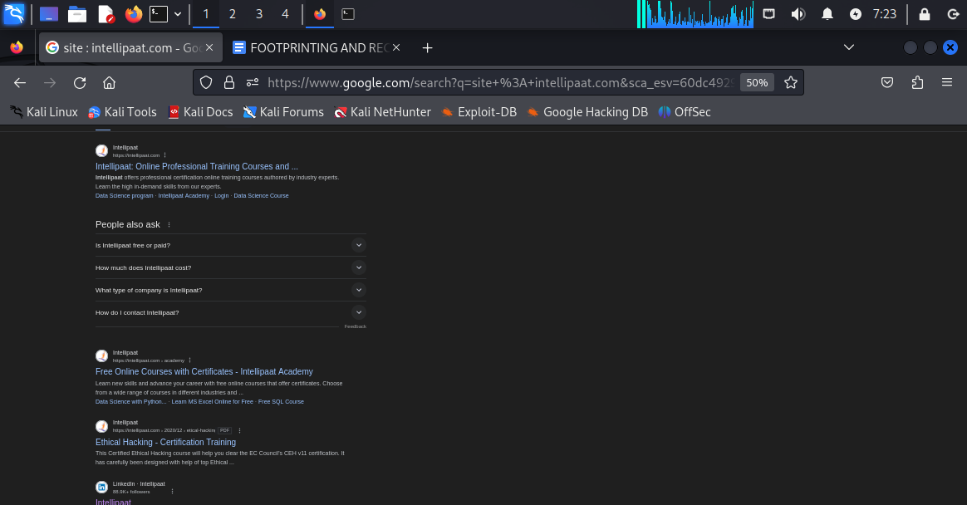

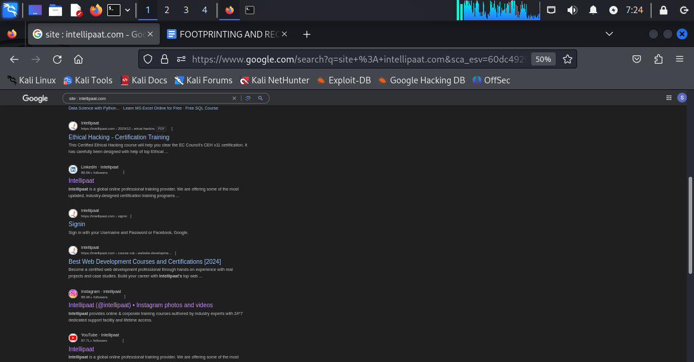

**Result of : site: intellipaat.com**

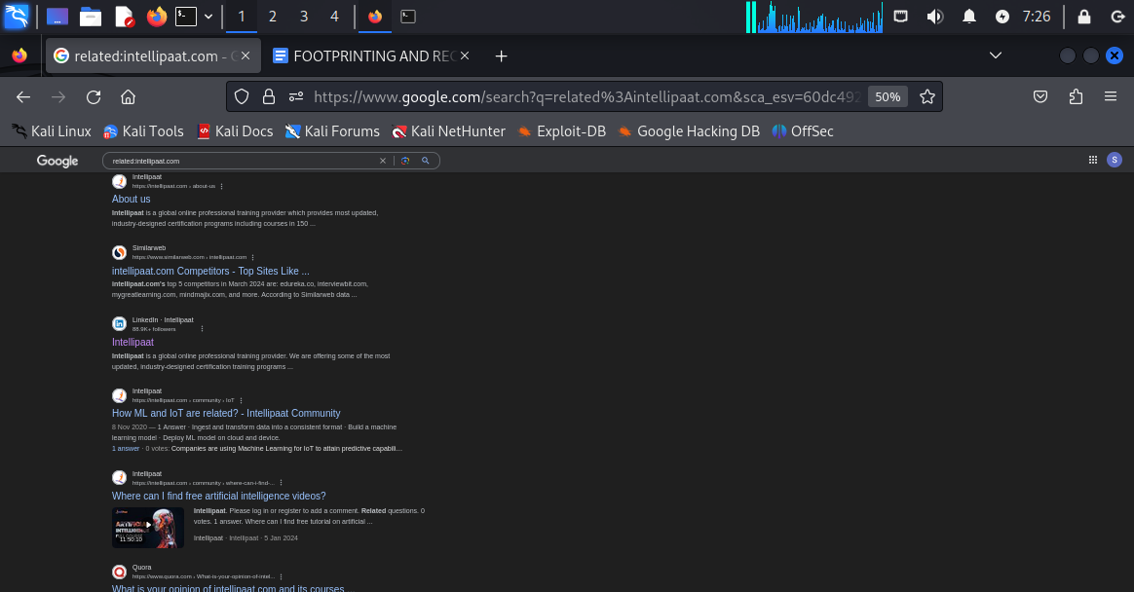

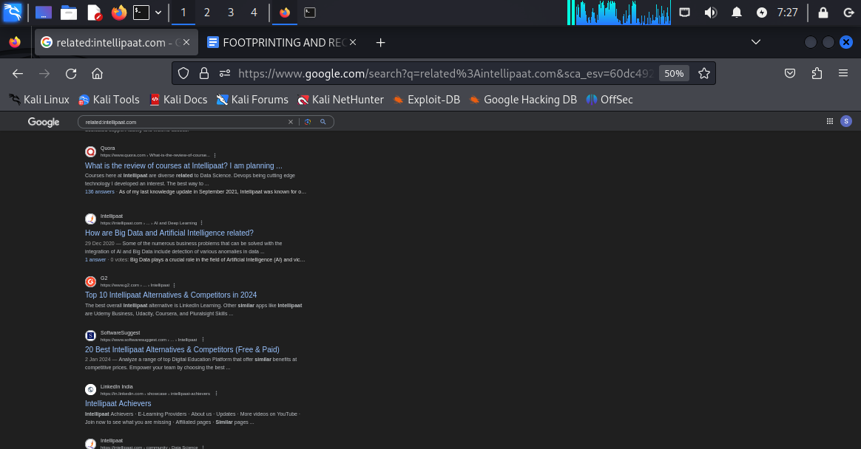

**Result of related:intellipaat.com**

**Observation: for site:intellipaat.com all the searches have come from intellipaat official website , domain and subdomains . we do not see any uploads from any third party website giving info about intellipaat but for related:intellipaat.com we have got the searches not only from intellipaat domain but also from other domains publishing information about intellipaat like “QUORA” , “G2” , “SOFTWARE SUGGEST”,”SIMILARWEB” .These are not intellipaat domains but the information are related to intellipaat .**

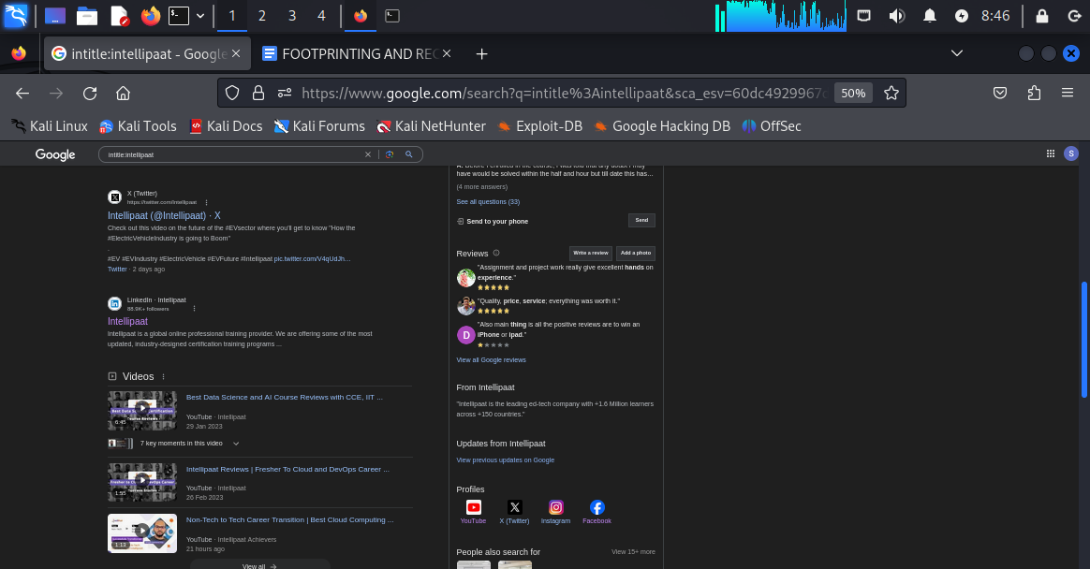

**Results from intitle:intellipaat.com**

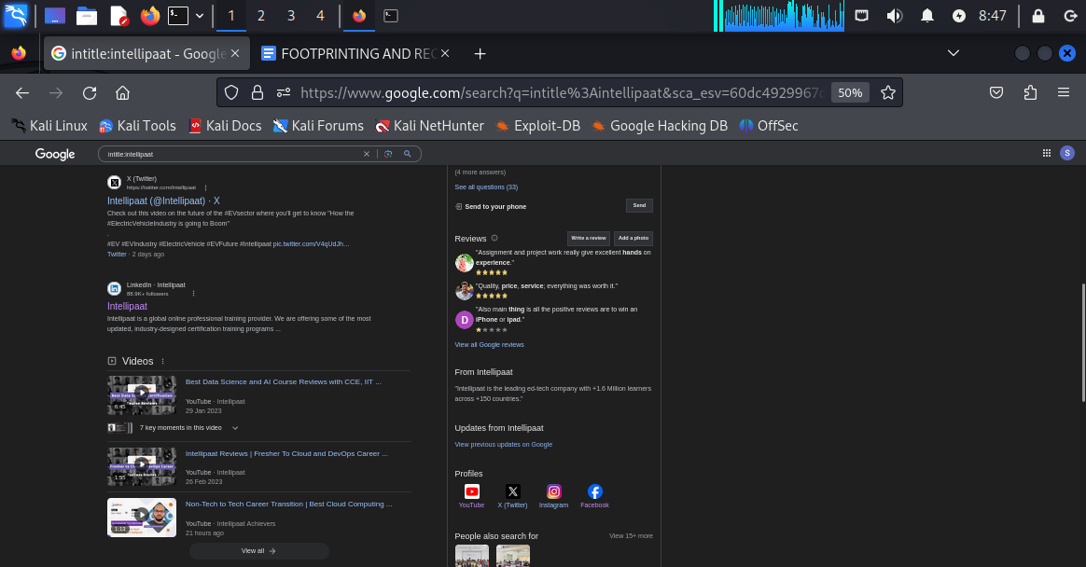

**Results from intitle:intellipaat**

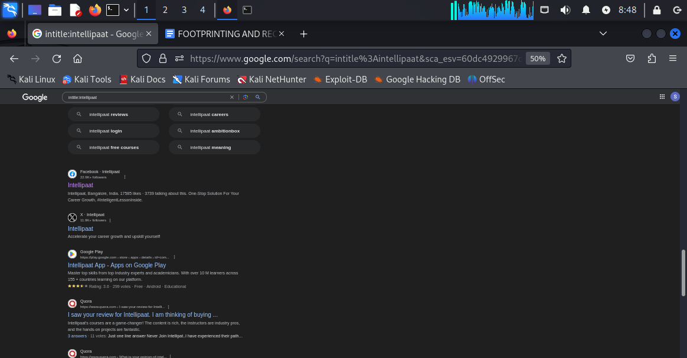

**Results from intitle:intellipaat**

**Observation: the result is the combination of both**

**site:intellipaat.com and related:intellipaat.com. So in the output we have both the combination of the output from intellipaat domain and other domains as well like quora, g2 etc.**

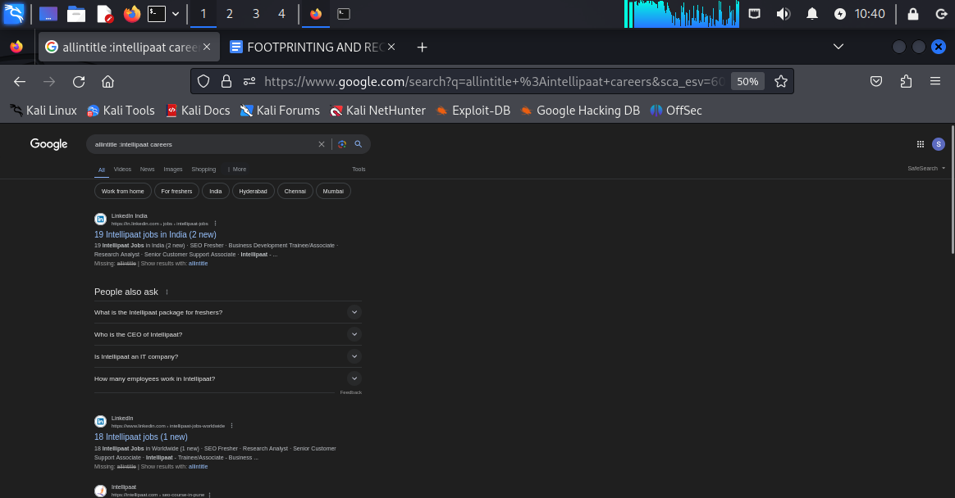

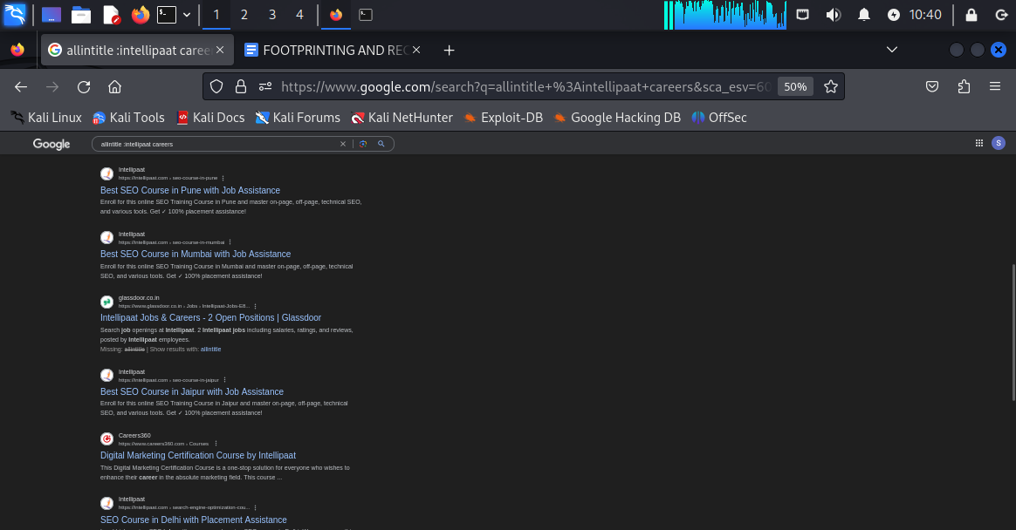

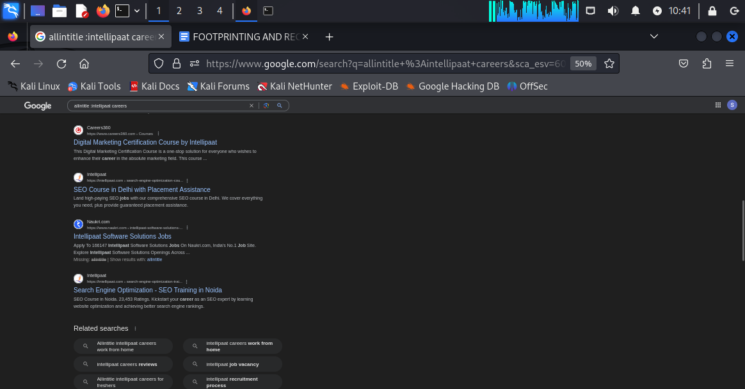

**Results from allintitle: intellipaat careers**

**Observation: we found all the searches related to jobs and careers and placements from intellipaat domain and other domains as well like NAUKRI.COM, CAREERS360, GLASSDOOR.CO.IN AND LINKEDIN INDIA.**

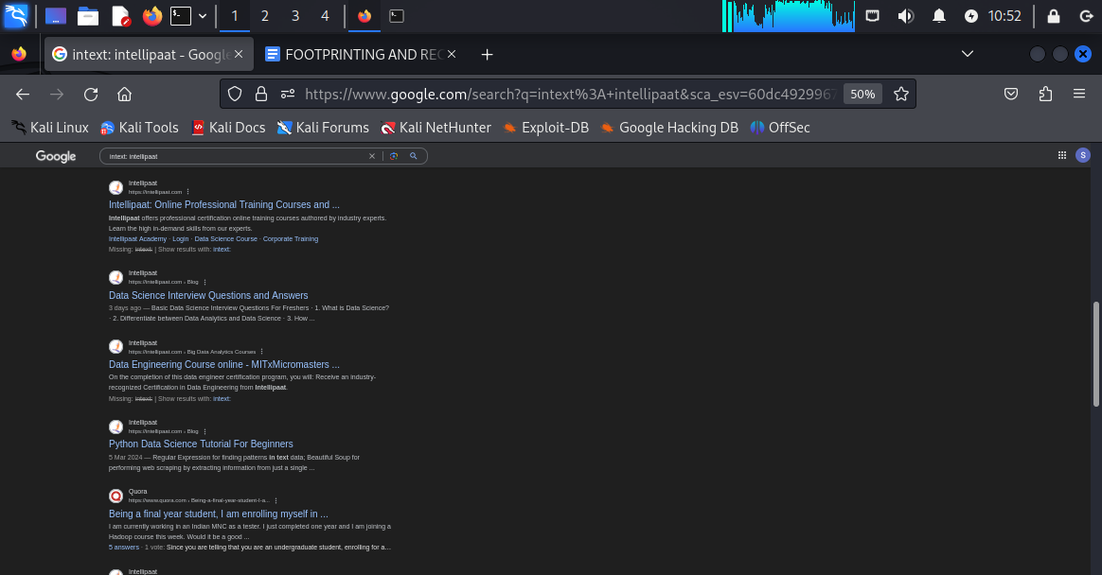

**Results from intext : intellipaat.com**

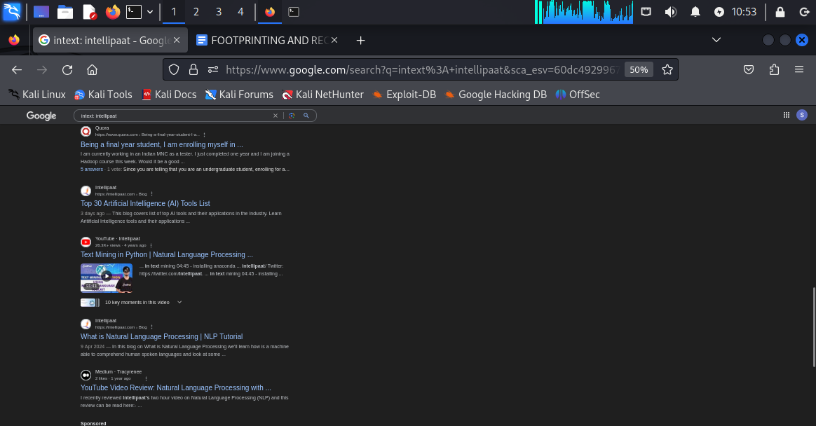

**Results from intext:intellipaat**

**Observation:all the searches are related to intellipaat regarding different topics and sections.**

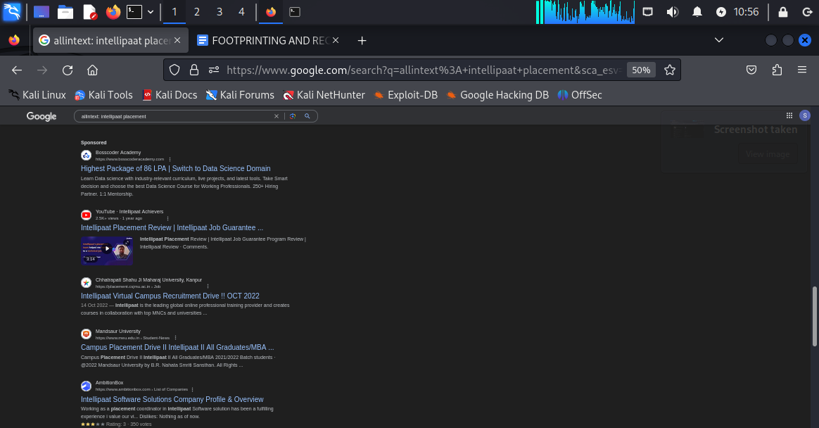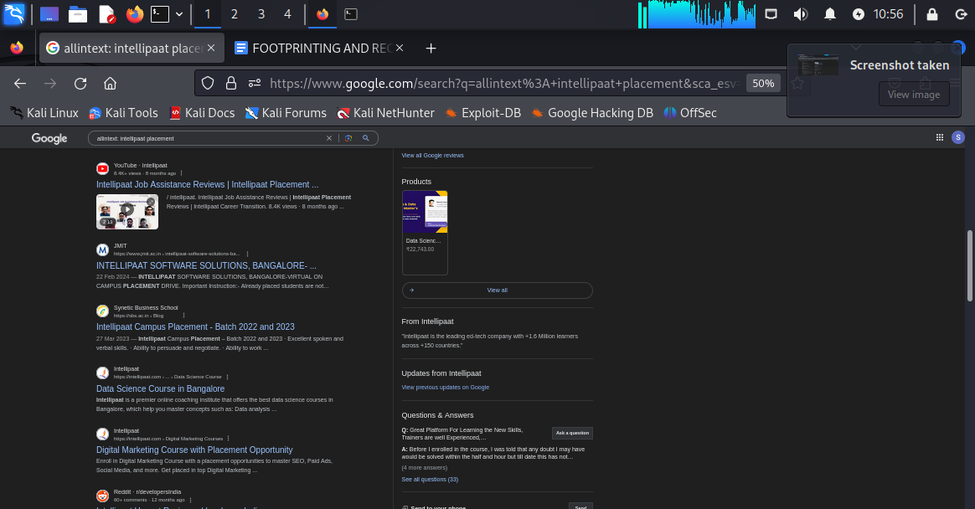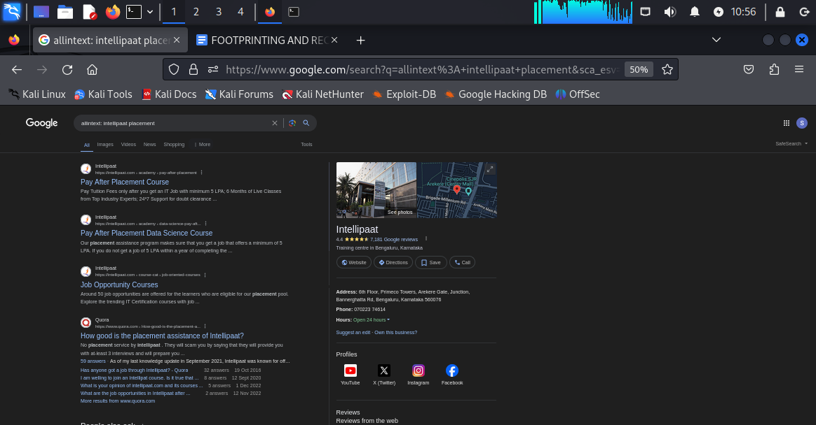

**Results from allintext:intellipaat placement**

**Observation:all the searches are from intellipaat or other domains but absolutely related to jobs and placements of intellipaat.**

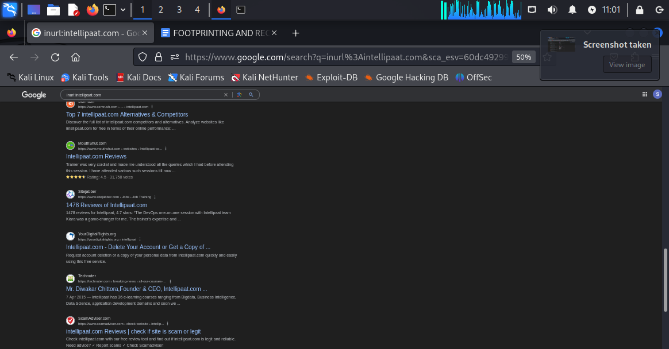

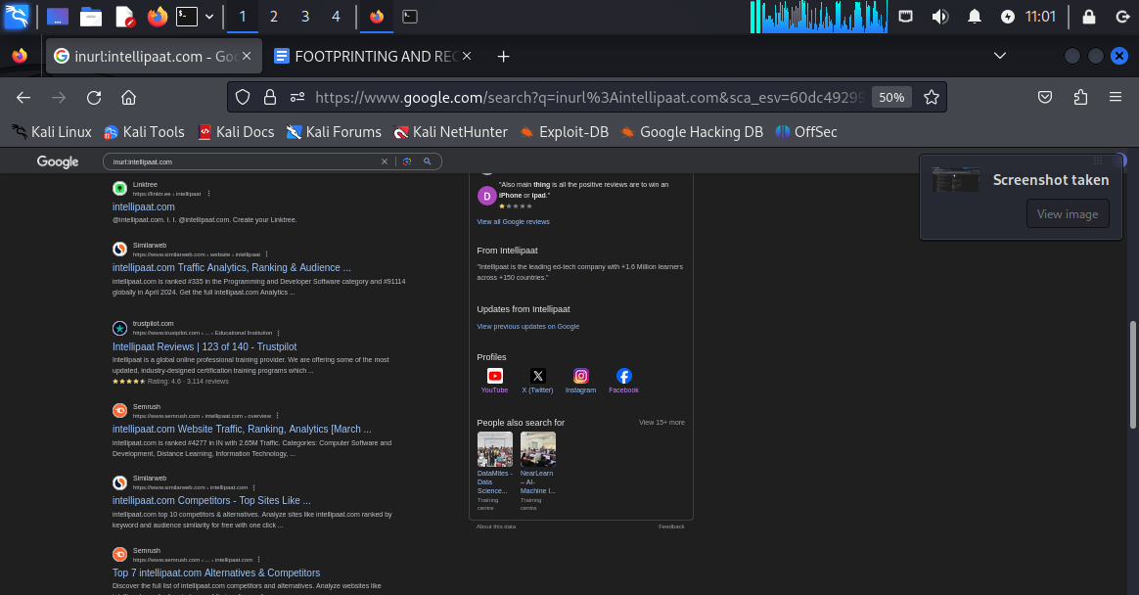

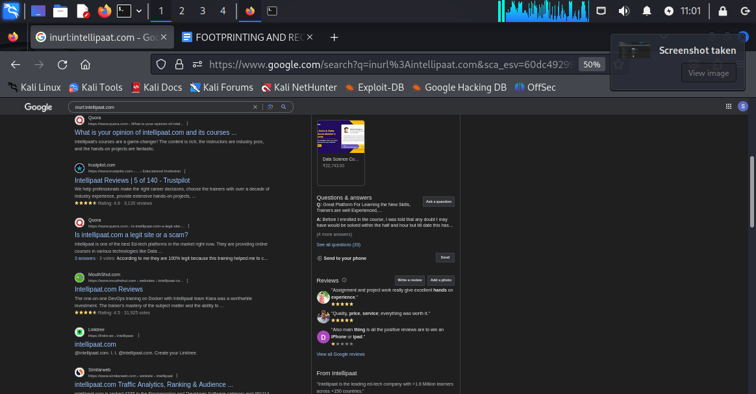

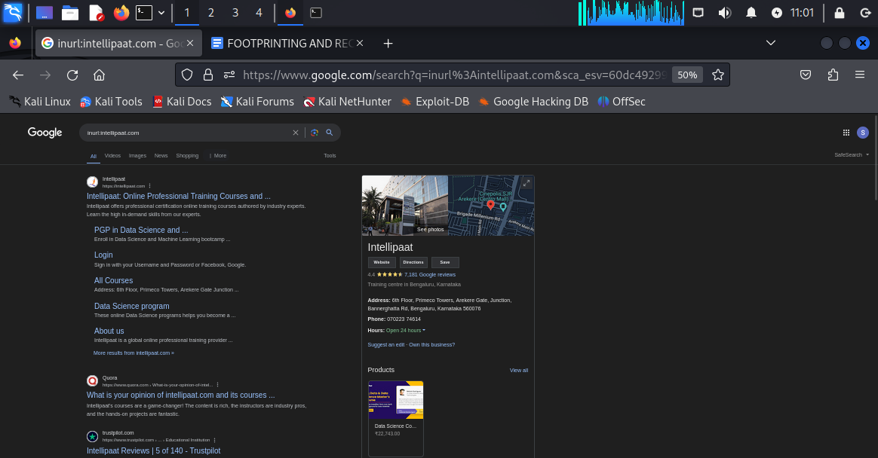

**Results from inurl:intellipaat.com**

**Observation:in this search we have found a handful of other domains like “mouthshut.com”,**

**“trustpilot.com”,”similarweb.com”,”scamadvisosr.com”,”yourdigitalrights.org”etc and all they contain is information about intellipaat.**

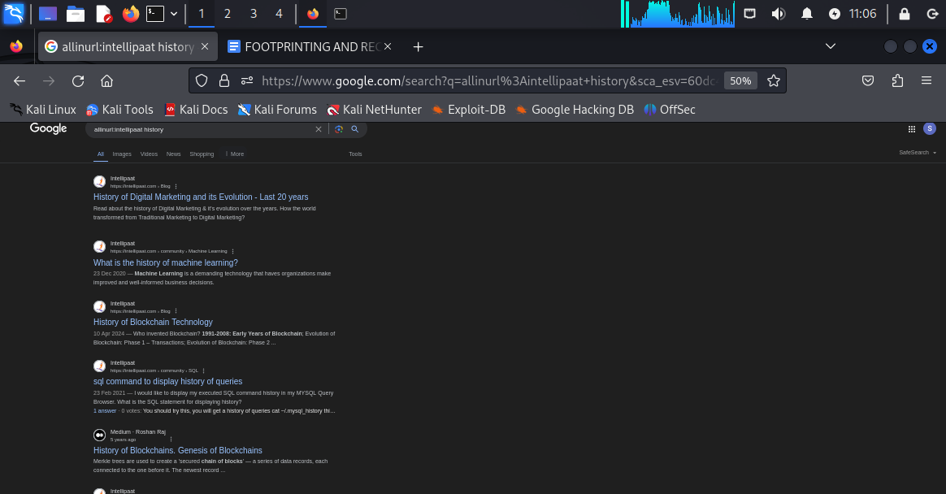

**Results from allinurl:intellipaat history**

**THERE ARE ALSO MANY OTHER ADVANCED GOOGLE SERACHES LIKE**

**1. Define:[word].....it will give the dictionary oriented meaning of that specific word.**

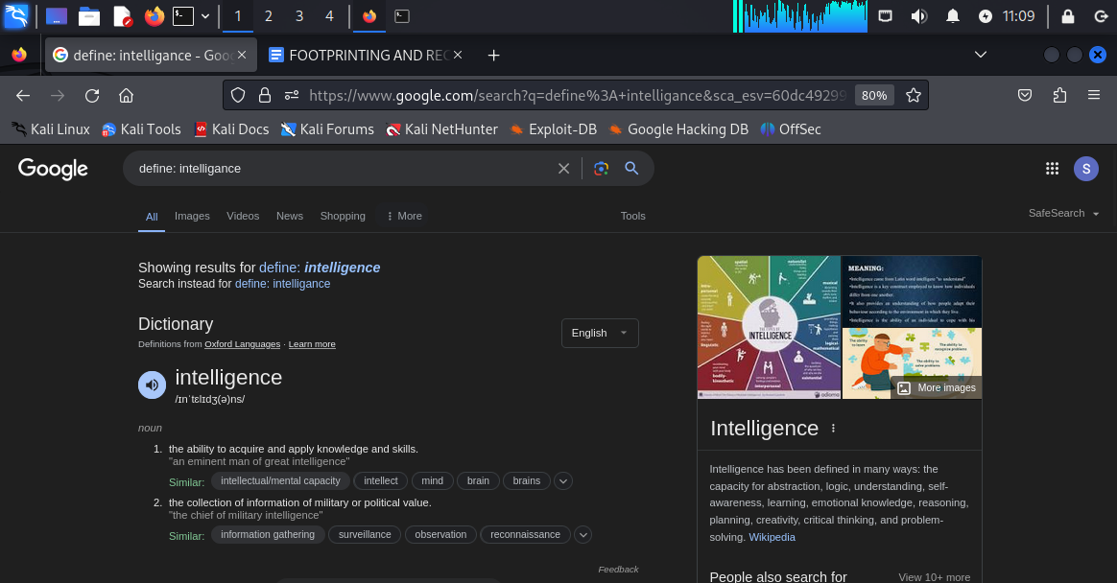

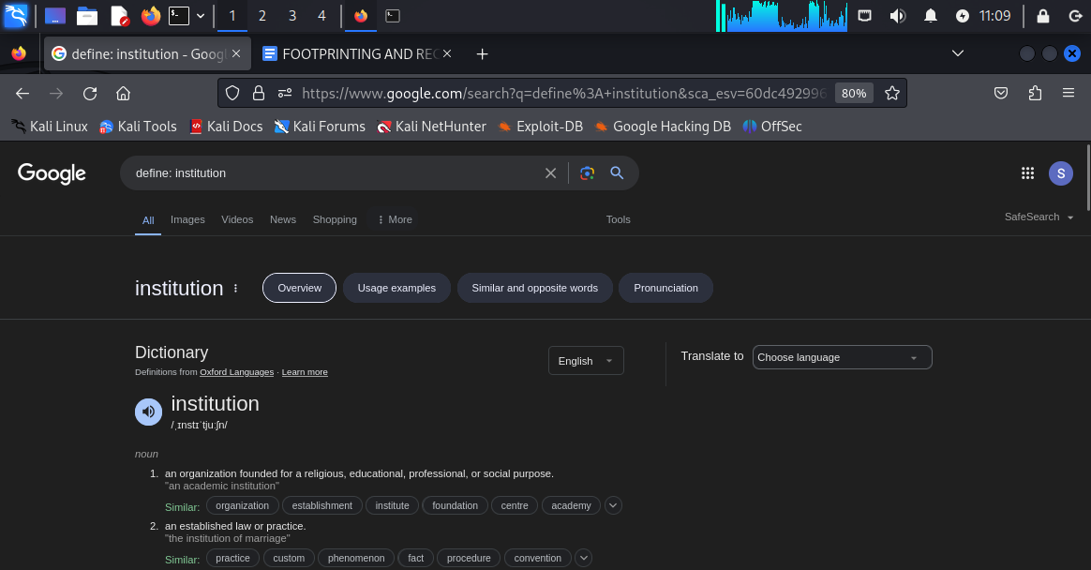

**This is one of the best ways of finding the meaning any word as per dictionary.**

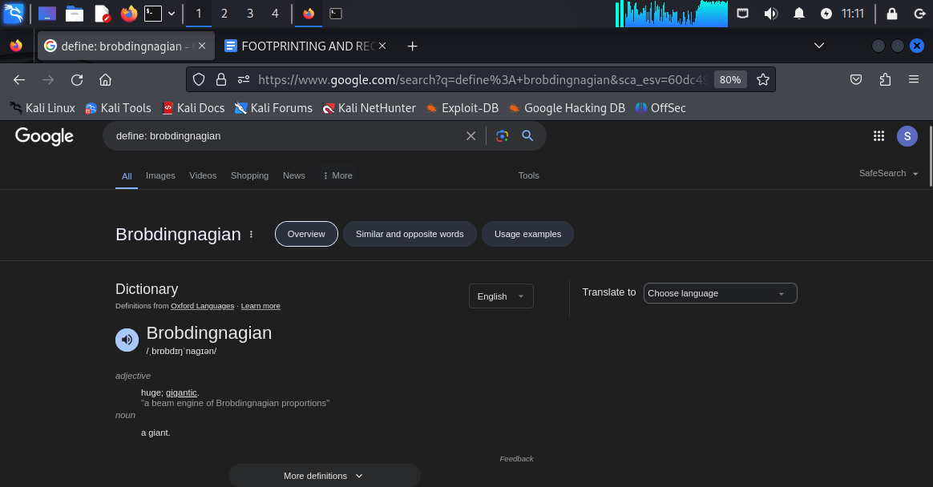

**Another example of the word “brobdingnagian”**

**2. Cache : intellipaat.com ……it will give us the latest cache version of any specific website.**





**Results from cache version of intellipaat.com website**

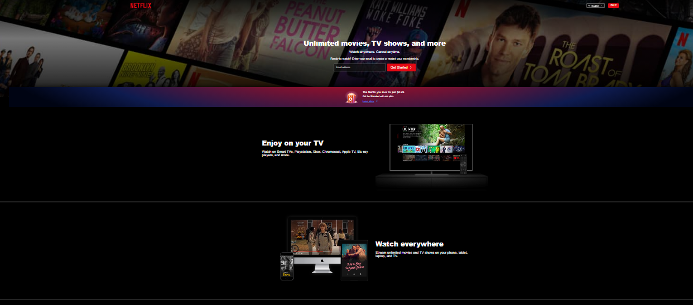

**This the cache version of netflix.com**

**3.intellipaat filetype:pdf**

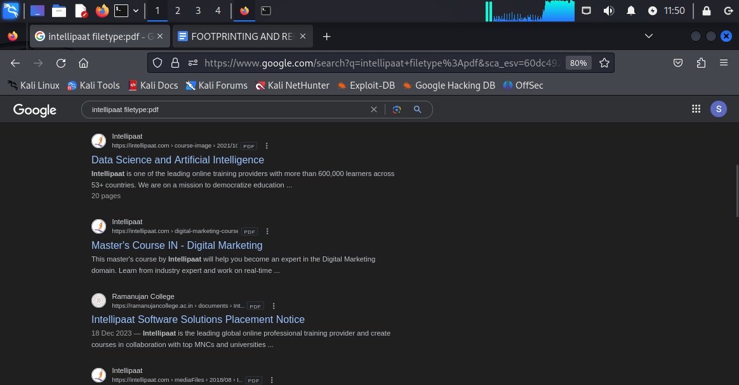

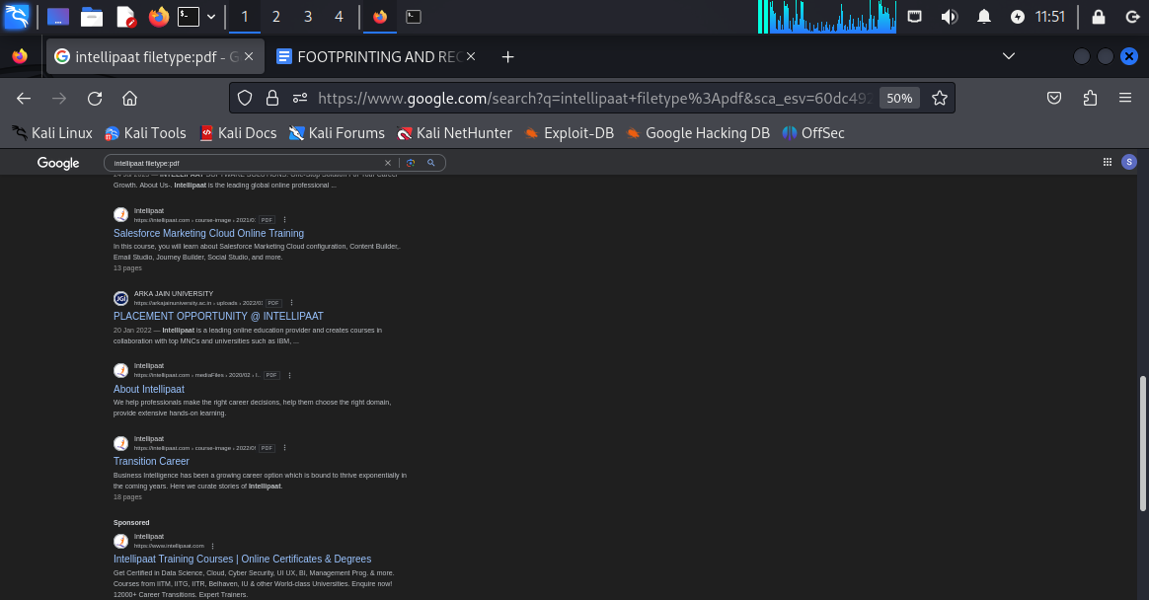

**Results from intellipaat filetype:pdf**

**Observation:we have found the pdf files directly from the web search and just by clicking on that we will be able to see the content of the pdf file.**

**4.weather:[location]**

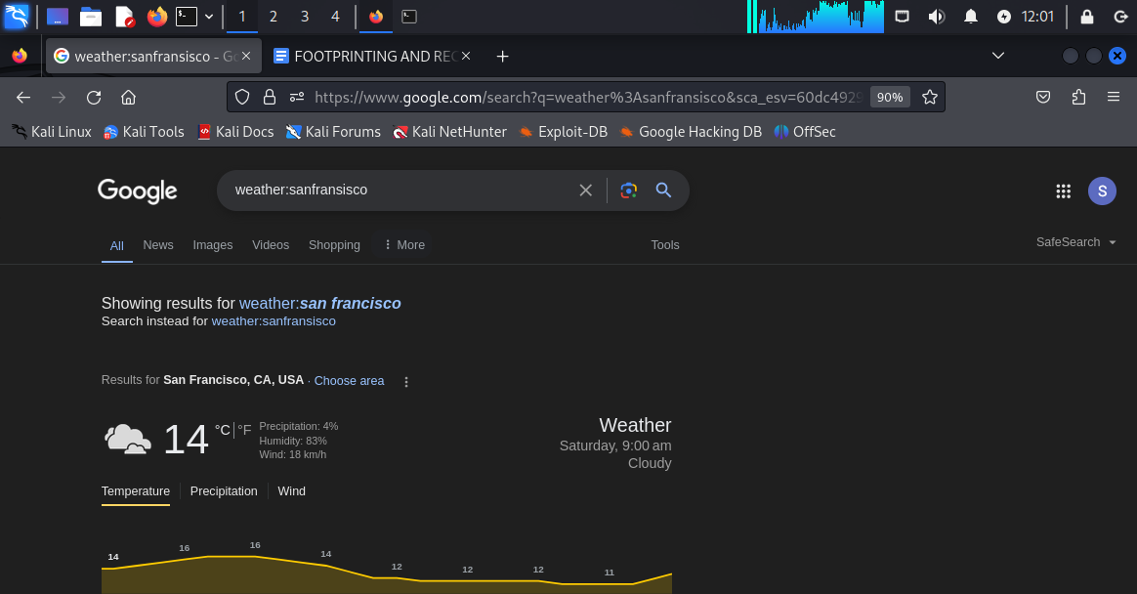

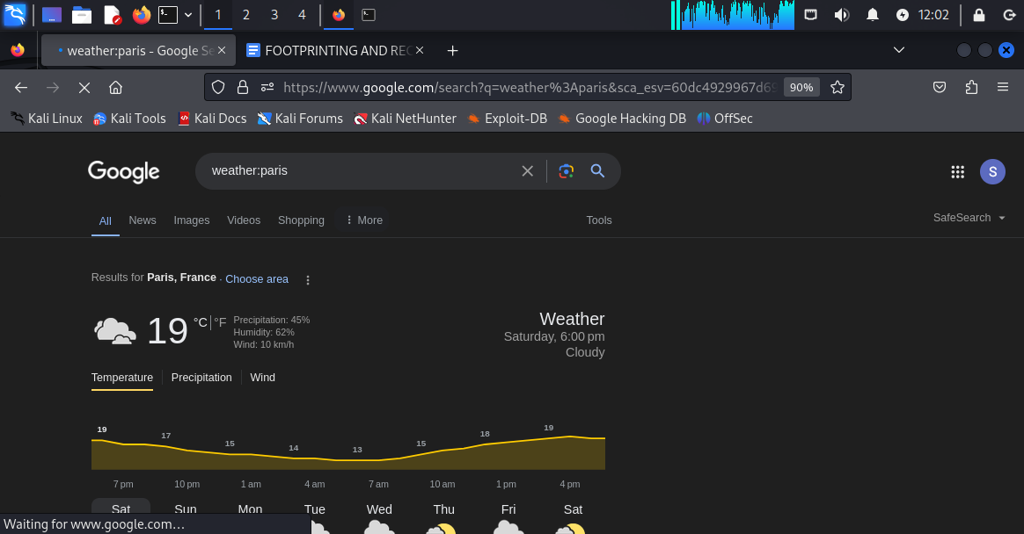

**Results for the weather for san fransisco and paris.**

**5.map[location]**

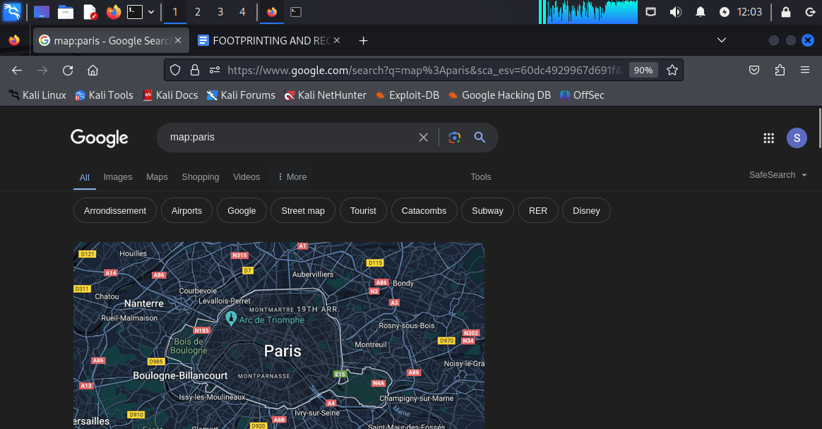

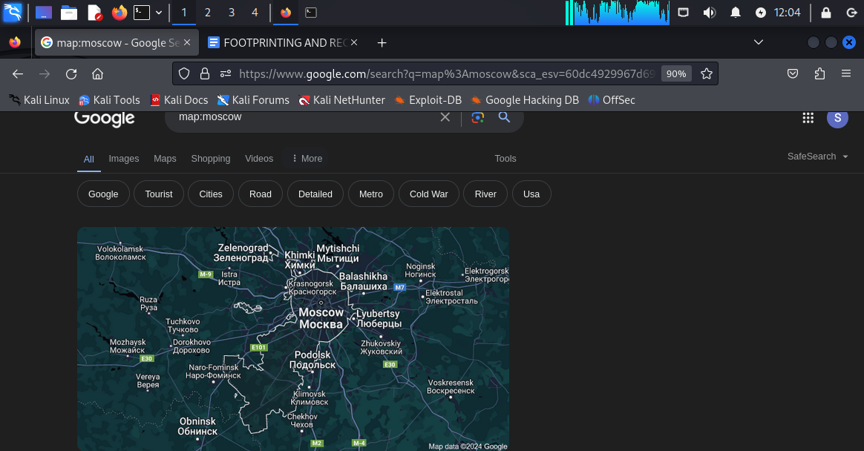

**Results for paris and moscow for map:[location]**

**FOOTPRINTING BY USING VIDEO SEARCH ENGINES BY USING mattw.io website.**

**Step1: first got to yoUTUBE AND SEARCH INTELLIPAAT CAREERS**



**STEP 2: SELECT ANY RANDOM VIDEO LIKE “ GET JOB OFFERS FROM TOP MNCs”**

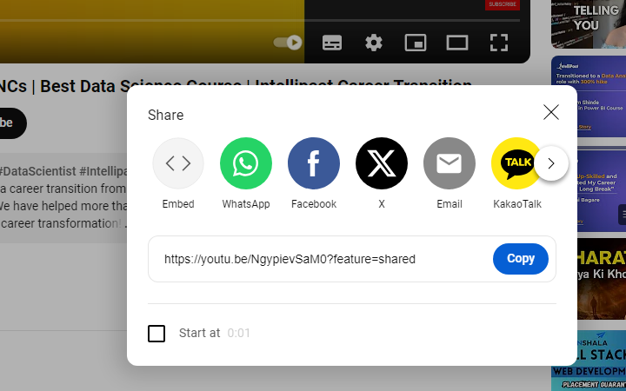

**Now we need to click on share>>then click on copy to copy the code.**

**Step3: go to mattw.io and click on “youtube metadata” and paste the code in the search box.**

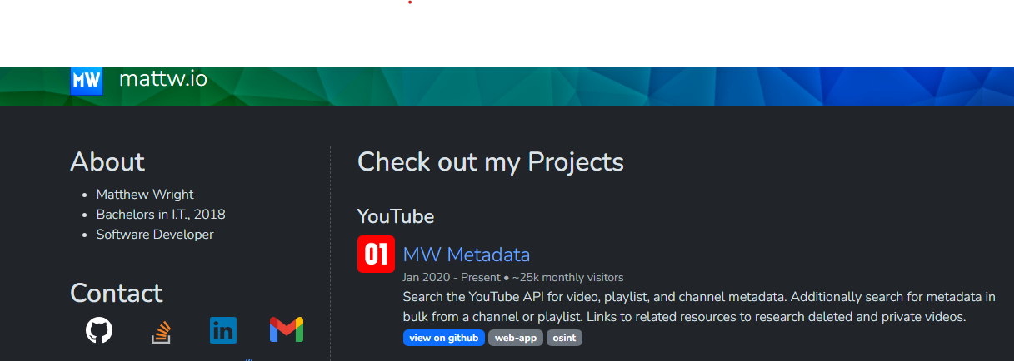

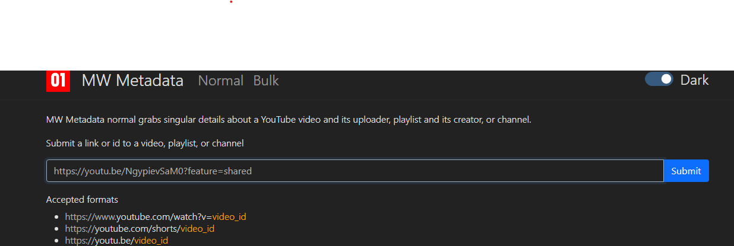

**Step4:after pasting the link in the box we need to click submit to find out all detailed info about this video regarding intellipaat.**

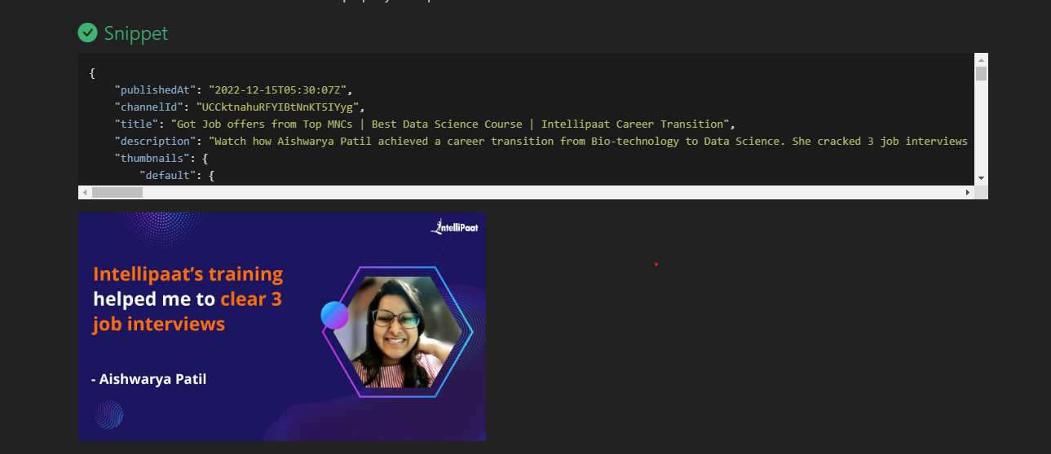

**NECESSARY DETAILS:**

1. **Channel id ::UCCktnahuRFYIBtNnKT5IYyg**
2. **Published date and time:2022-12-15T05:30:07Z**

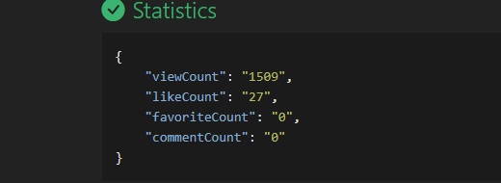

**Information about**

**Viewcount: “1509”**

**Like count: “27”**

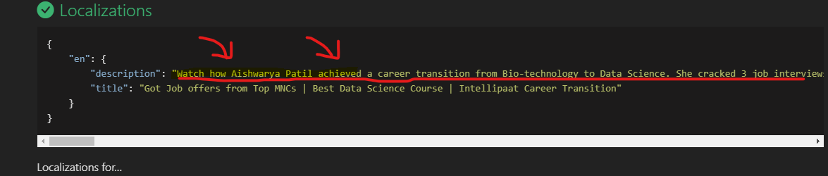

**We can see the main objective of the entire video where a lady named “AISHWARYA PATIL” achieved a career transition from bio-technology to data science and she cracked 3 job interviews.**

**Objectives: without watching the video we can gather all the information or meta data about the video.**

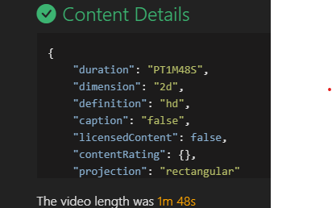

**We can see the graphical description about the video for example dimension and definition and projection**

**Likewise we can do video search about any domain or website with matte.io**

**FOOTPRINTING BY USING** [**www.website.informer.com**](http://www.website.informer.com) **and** [**www.netcraft.com**](http://www.netcraft.com) **and shodan.io**

**1.**[**www.website.informer.com**](http://www.website.informer.com)

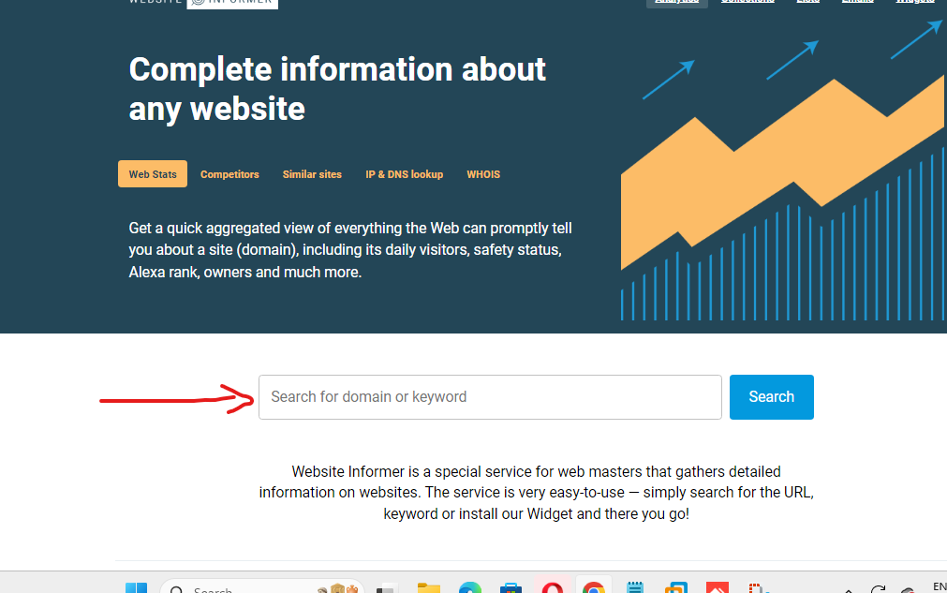

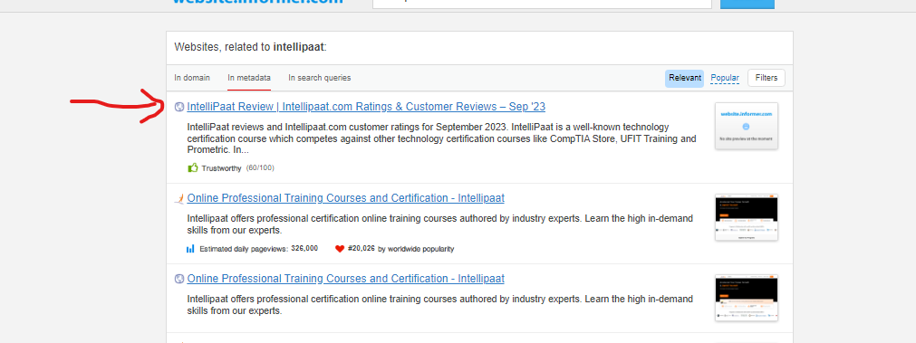

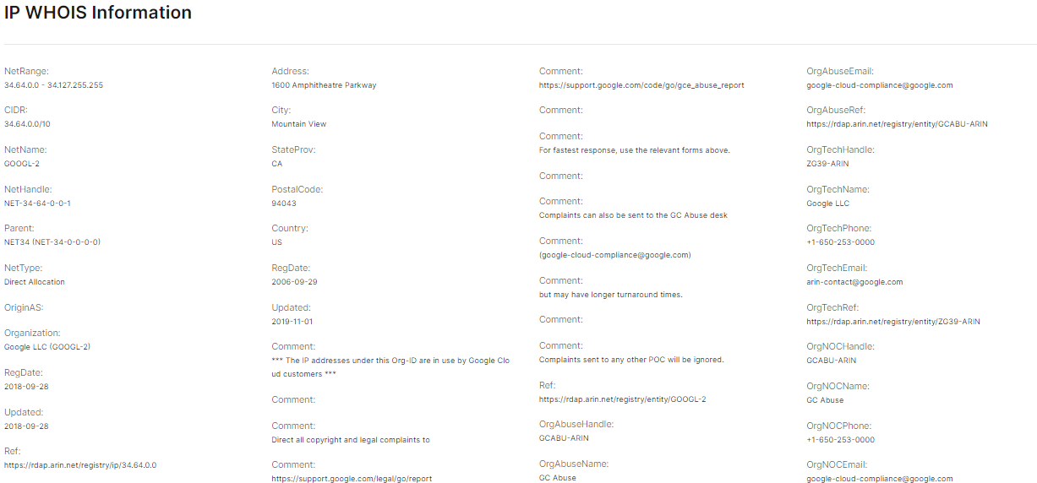

**As we can see that there is a heap of information regarding ONE SPECIFIC INTELLIPAAT WEBPAGE .**

**NETRANGE : 34.64.0.0….34.127.255.255**

**ADDRESS: 1600 AMPITHEATRE PARKWAY MOUNTAIN VIEW CALIFORNIA 94043 USA.**

**REGISTRATION DATE: 29TH SEPTEMBER 2006**

**THESE ARE IP WHOIS INFORMATION**

**2.**[**WWW.NETCRAFT.COM**](http://www.netcraft.com)

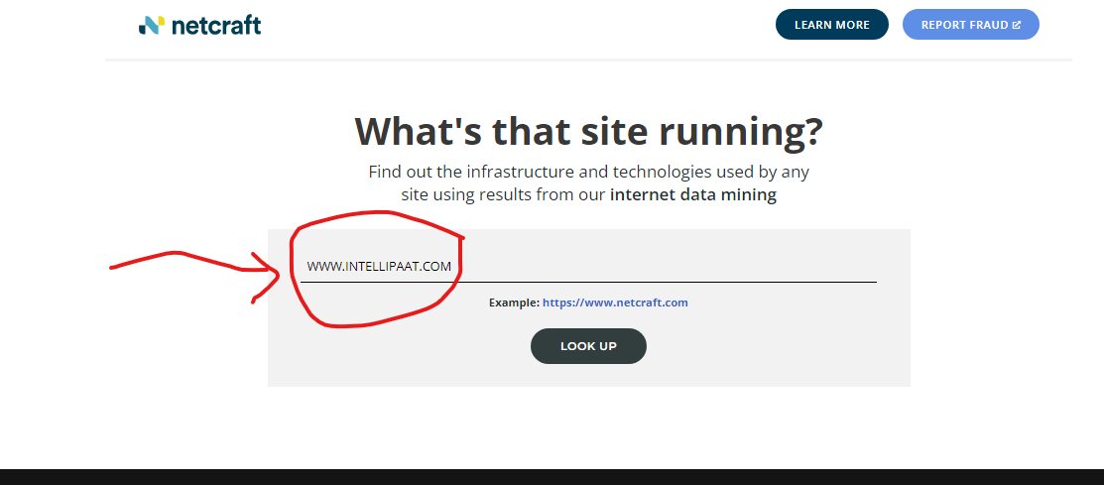

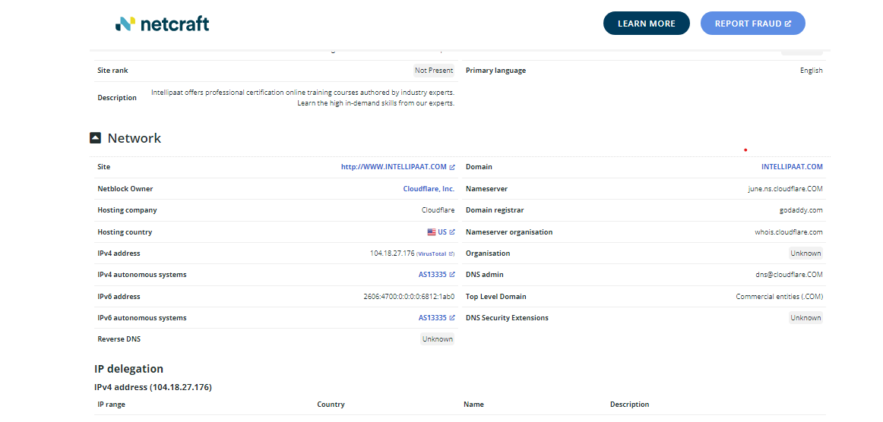

**OBSERVATION:**

**INTELLIPAAT DOMAIN IP ADDRESS:104.18.27.176**

**NETBLOCK OWNER: CLOUDFLARE.INC.**

**IPV6 ADDRESS: 2606:4700:0:0:0:0:6812:1ab0**

**Domain registrar: godaddy.com**

**Dns admin:** [**dns@cloudflare.com**](mailto:dns@cloudflare.com)

**NEGATIVE REVIEWS ABOUT INTELLIPAAT FROM DIFFERENT SURVEY ORIENTED WEBSITES SUCH AS trustpilot.com , glassdoor.co.in or mouthshut.com**

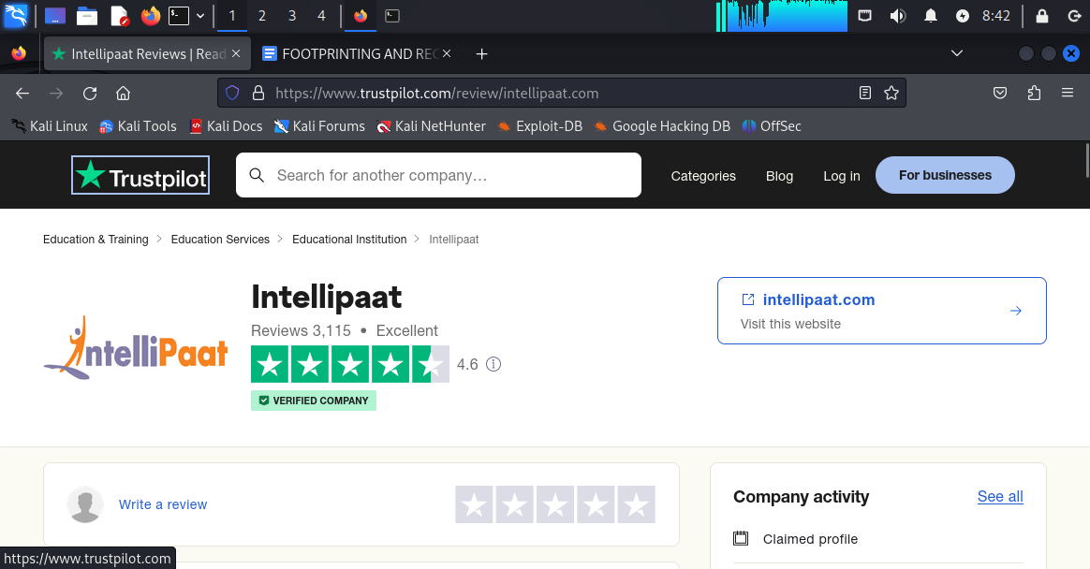

**4.5 out of 5 in trustpilot.com**

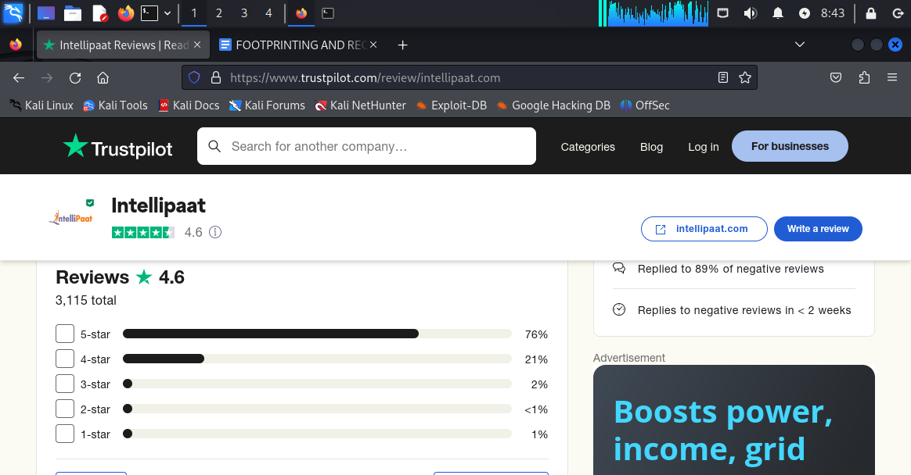

**Percentage based on rating**

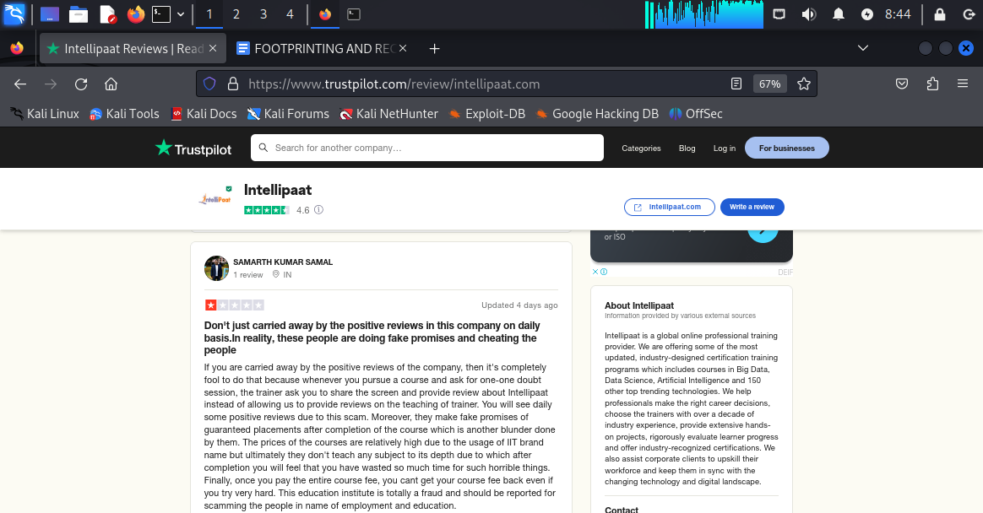

**One negative review about intellipaat**

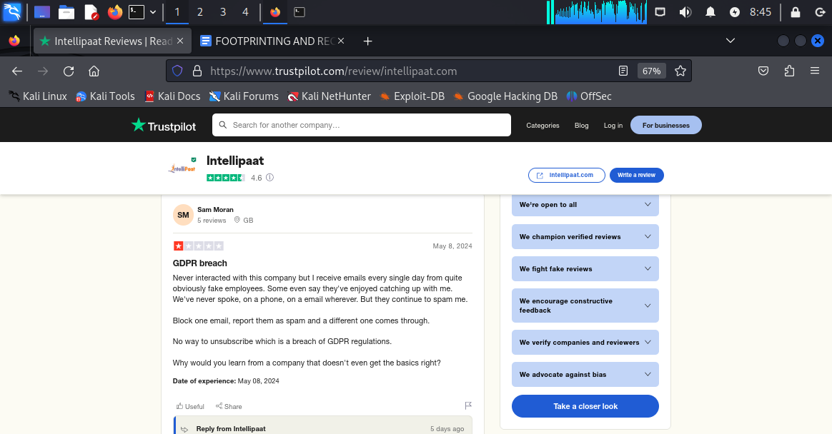

**Second negative review about intellipaat**

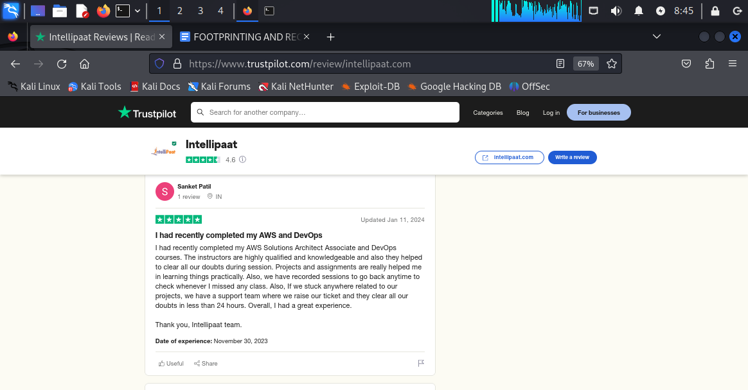

**Positive feedback about intellipaat.**

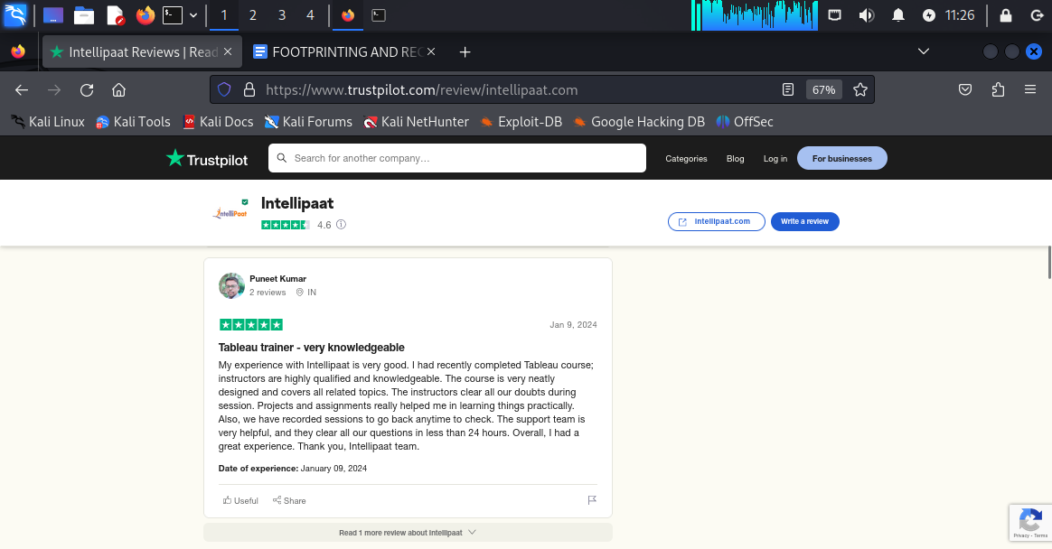

**Positive feedback about intellipaat.com**

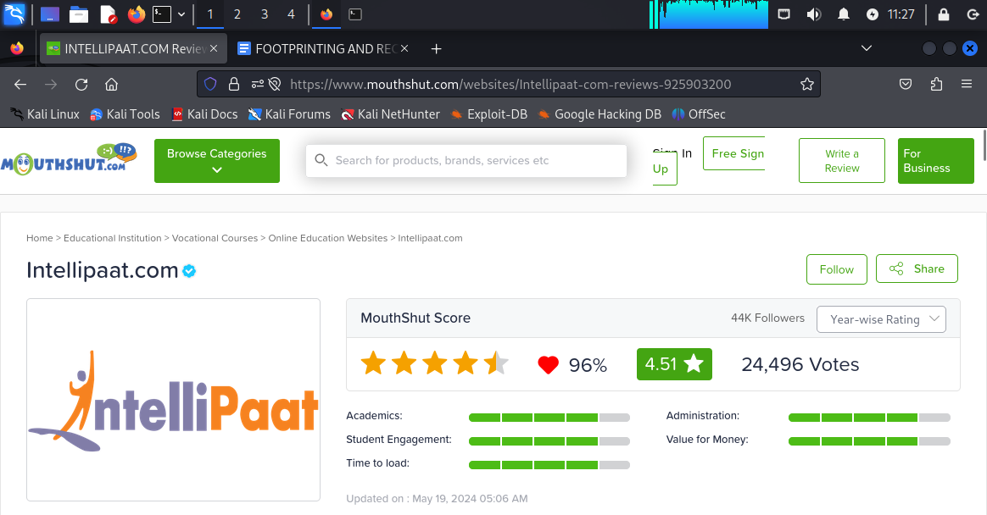

**mouthshut.com statistics.**

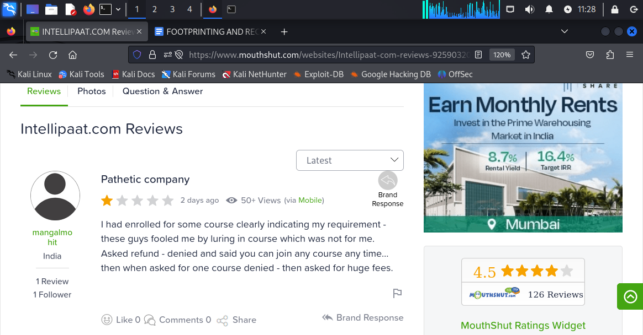

**Negative reviews about intellipaat.com**

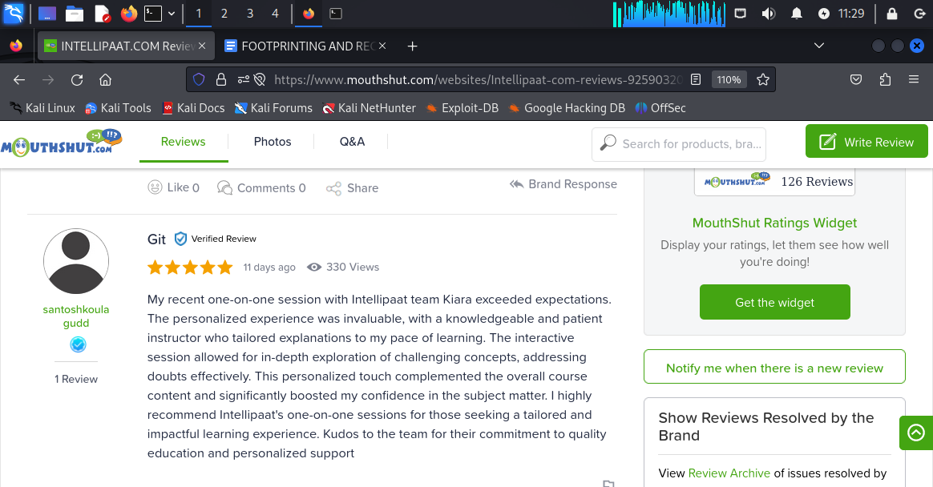

**Positive review about intellipaat.**

**This is how we can collect the information about the public review of a specific domain by using the advanced google search which is reviews:intellipaat[domain name]**

IMPLIMENTATION OF nikto TO FIND OUT WEBSITE VULNERABILITIES:

VICTIM IP : 192.168.189.135(METASPLOITABLE 2 MACHINE)

Command: nikto -h 192.168.189.135

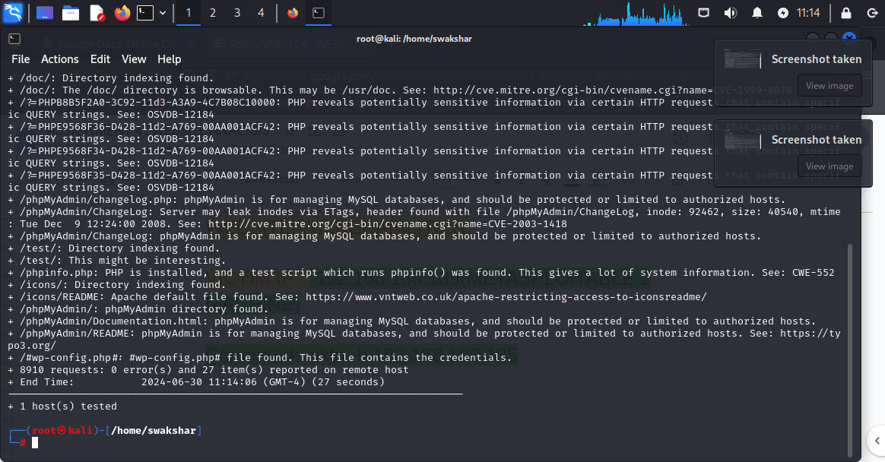

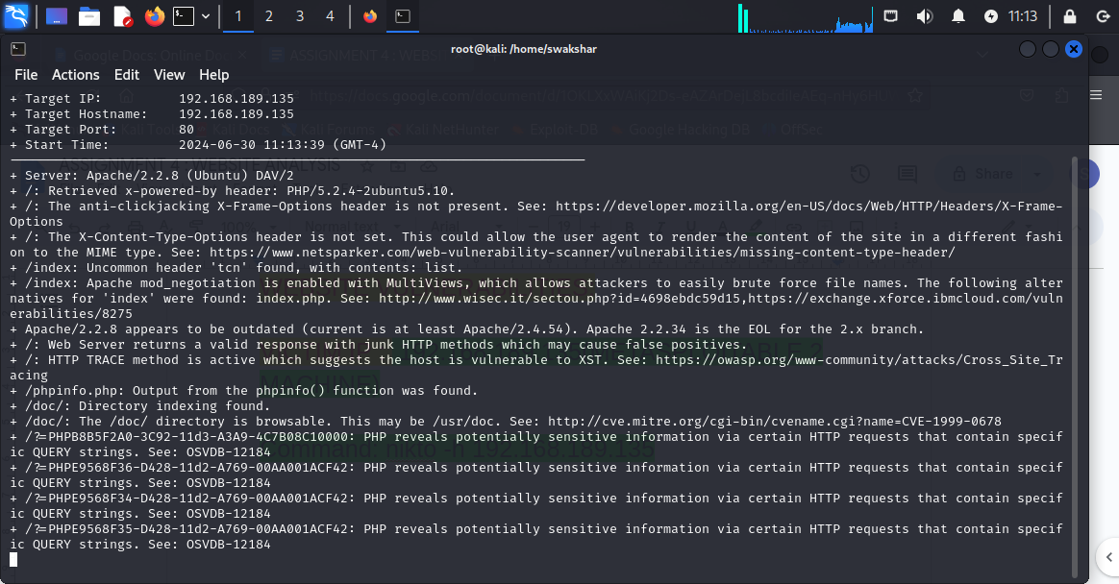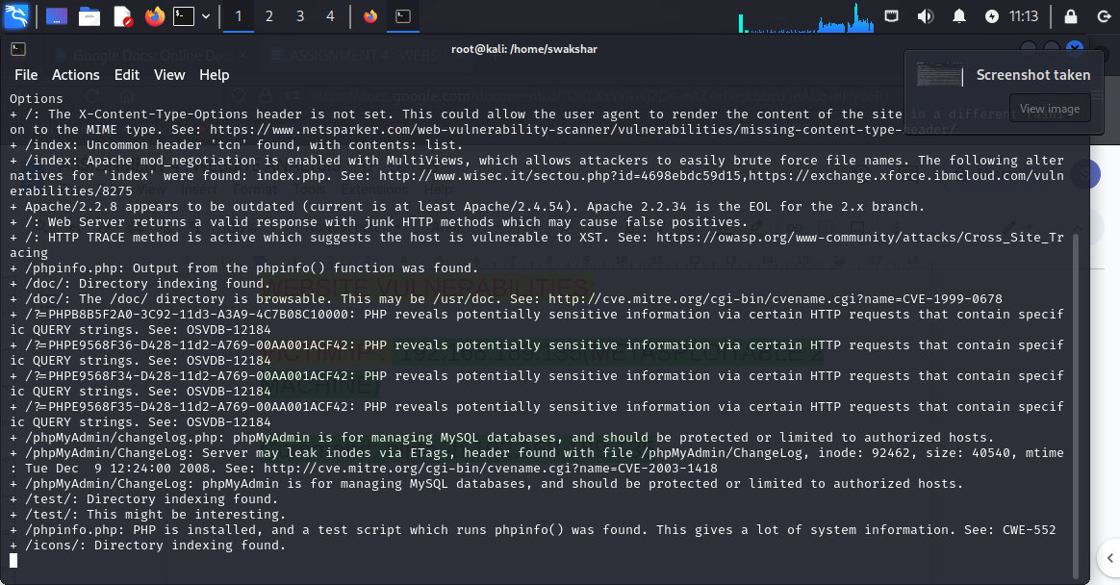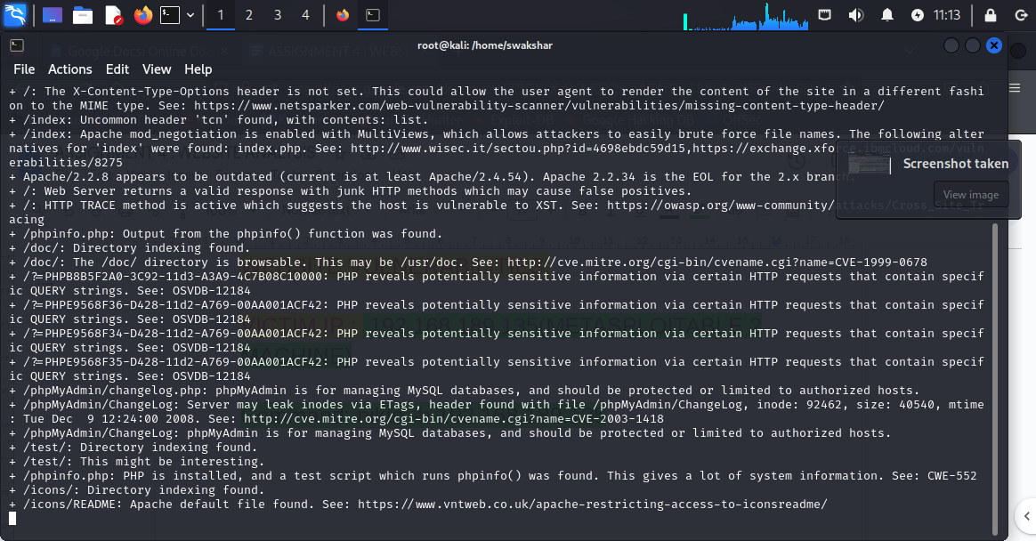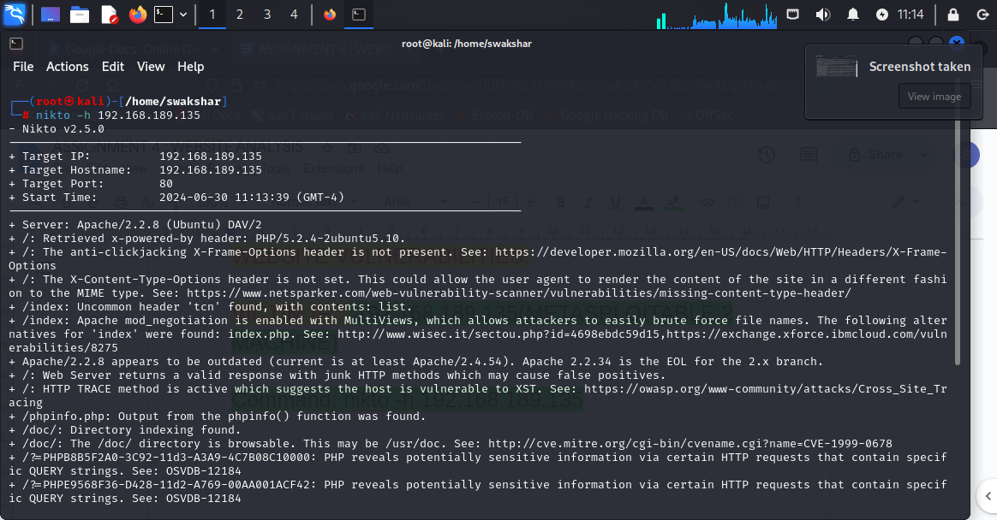

Command 2: nikto -h 192.168.189.135 -p 80

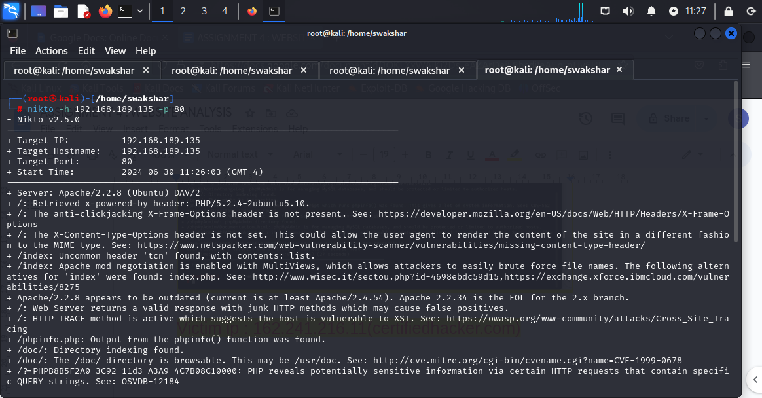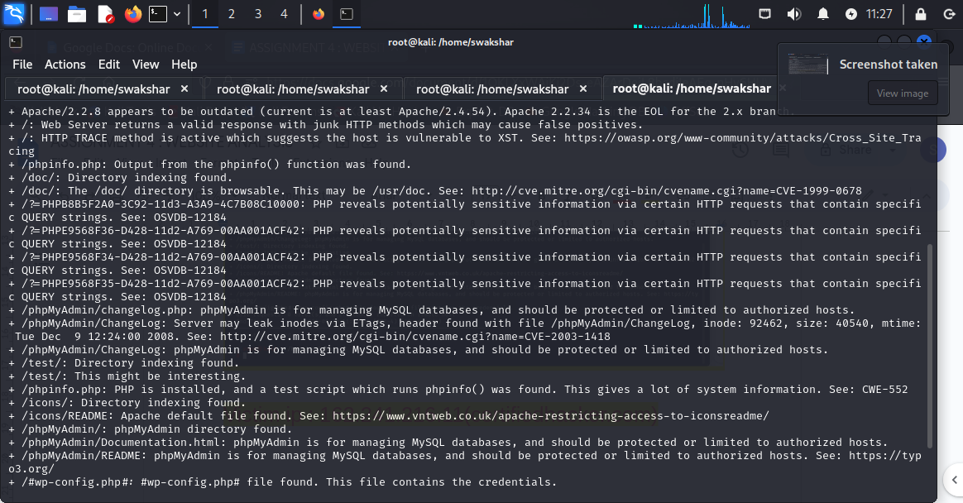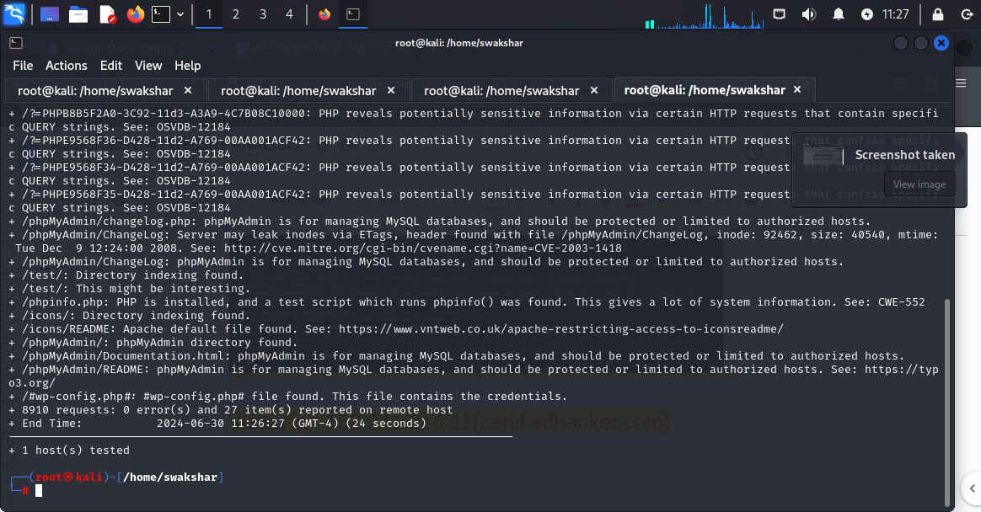

So we can see that by not using the [-p 80] we have got in general vulnerabilities for our metasploitable machine but by using the command **nikto -h 192.168.189.135 -p 80** we have got specific vulnerabilities of the port 80 which is the http server

Protocol of our victim machine.

Command3: nikto -h 192.168.189.135 -ssl

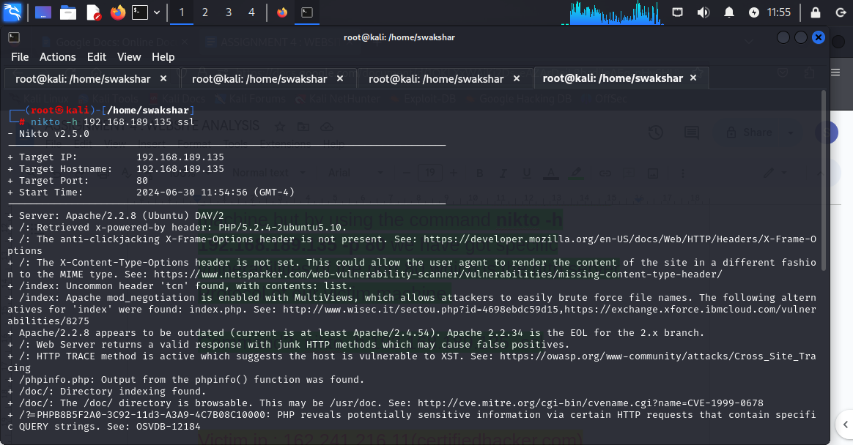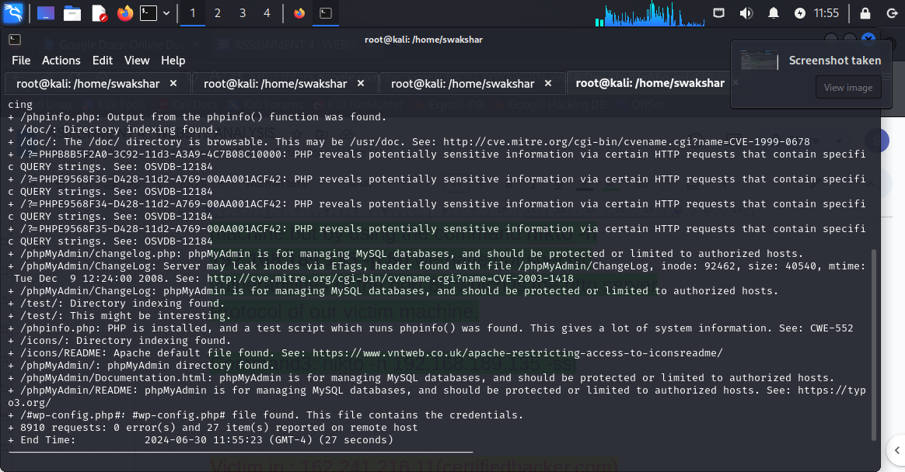

The command nikto -h 192.168.189.135 -ssl will give us all the potential vulnerabilities about the ssl.

Victim ip: 13.56.33.8[[www.moviescope.com](http://www.moviescope.com)]

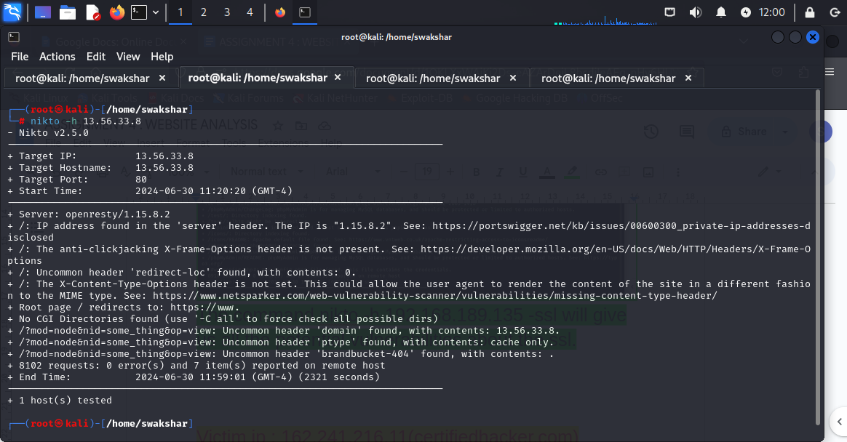

Victim ip: 107.180.0.47[[www.goodshopping.com](http://www.goodshopping.com)]

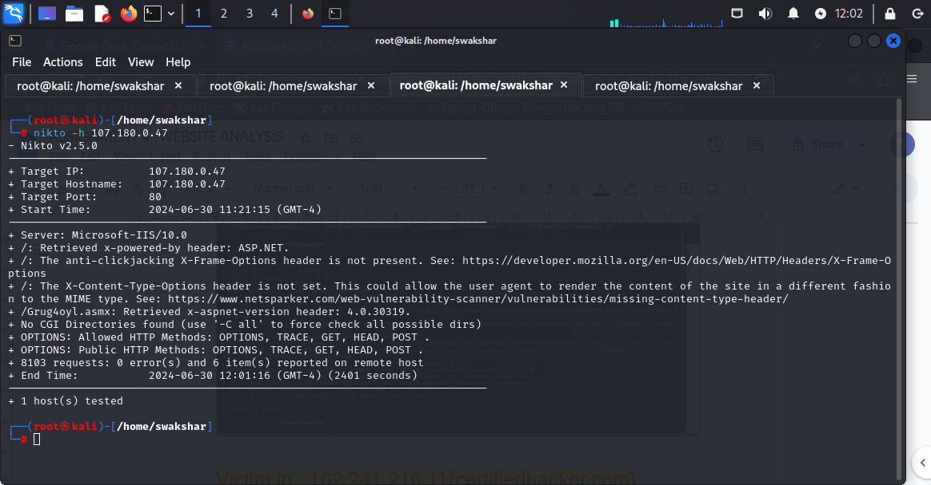

Victim ip: 162.241.216.11

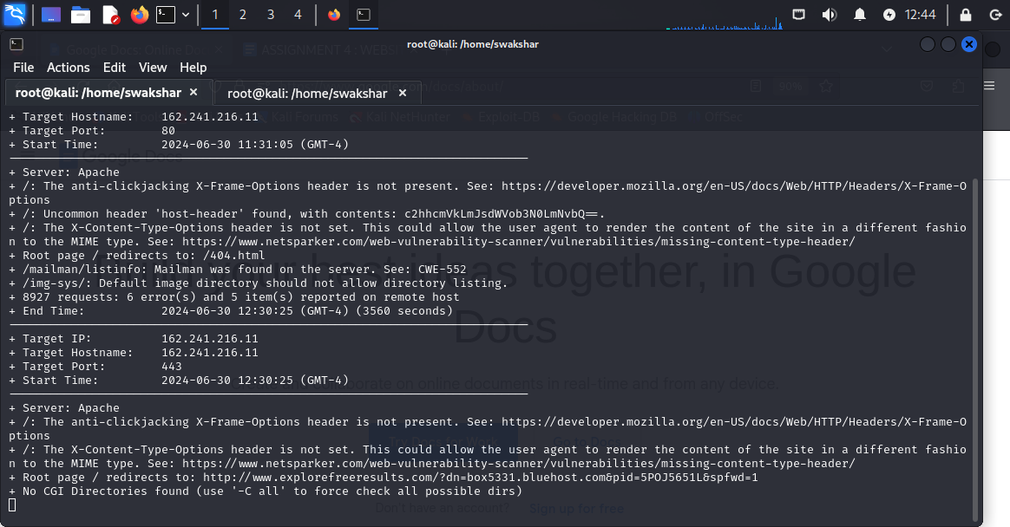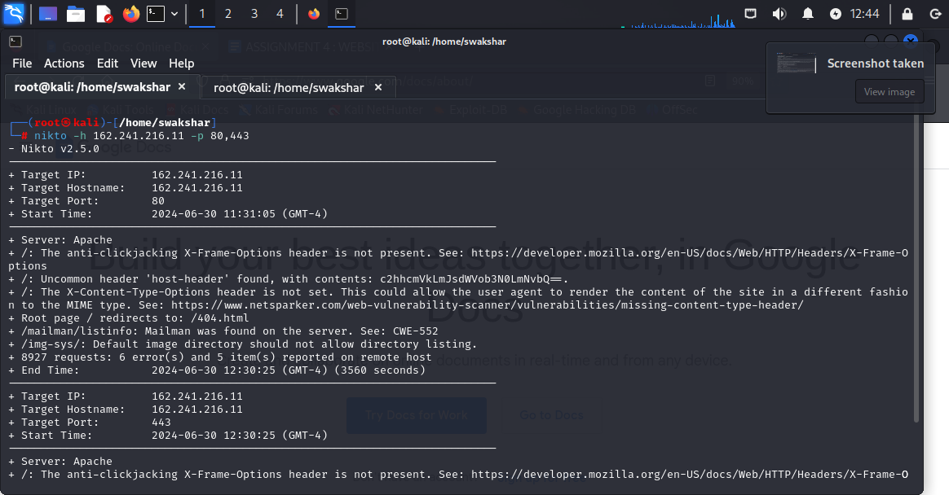

Potential vulnerabilities discovery:

1.web server version

2.http header

3.the anti-clickjacking x frame options about header

4.the x-content type questions about header

5.apache mod_negotiation enabled with multiviews which allows the hacker to perform brute-force attack

6.the updates about the operating system and whether it is patched\unpatched

7.which filess/documents are browsable

8.phpMyAdmin is for managing MySQL databases so it should be protected or limited to authorised hosts.

9.whether php is installed and a test script was found which runs phpinfo().this is very much vulnerable

10.how many ways sensitive information can be exposed to the attacker about the system like groupnames,user account,sam file[security access manager], hashed passwords etc.

**APPLICATION OF NESSUS FOR VULNERABILITY ANALYSIS:**

**STEP1:**

**DOWNLOAD nessus from any web browser**

**Step2:**

**Go to your vm ware machine>>click on the downloaded file>>right click>>open in new terminal**

**Step3:**

**Type “ls” and then type dpkg -i [name of the file]**

**Step4:**

**Create a new username and password in nessus**

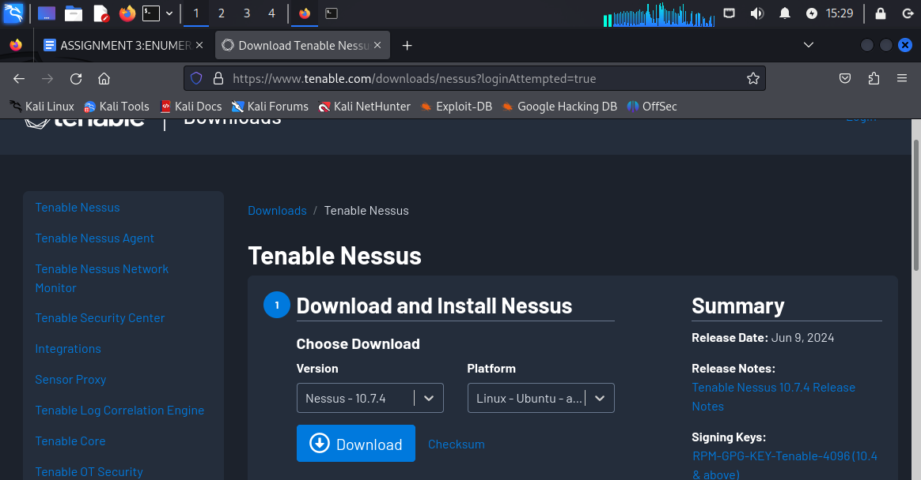

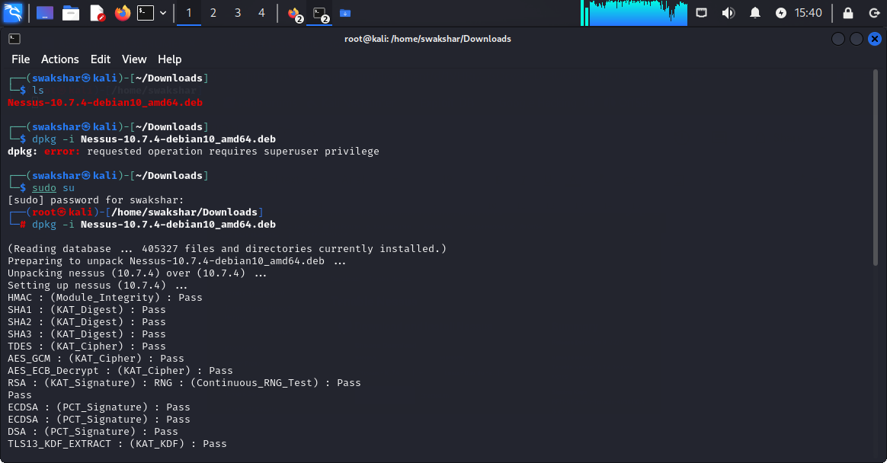

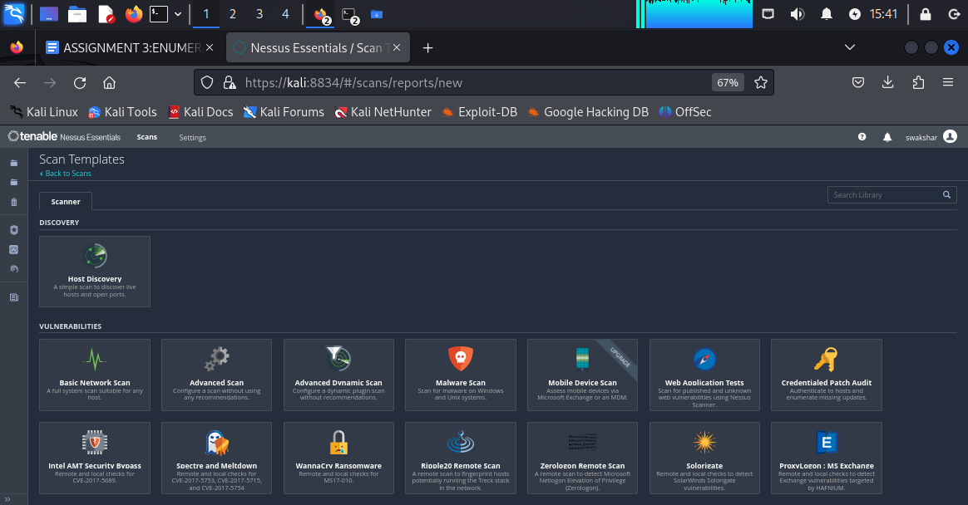

**The homepage of nessus 👍**

**Performing host-discovery by using nessus:**

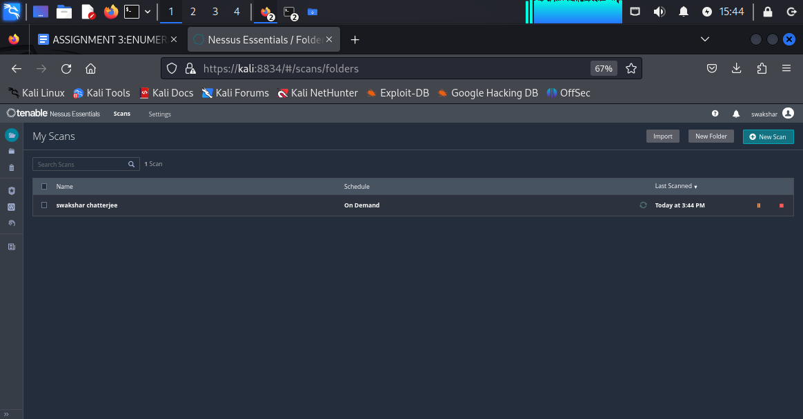

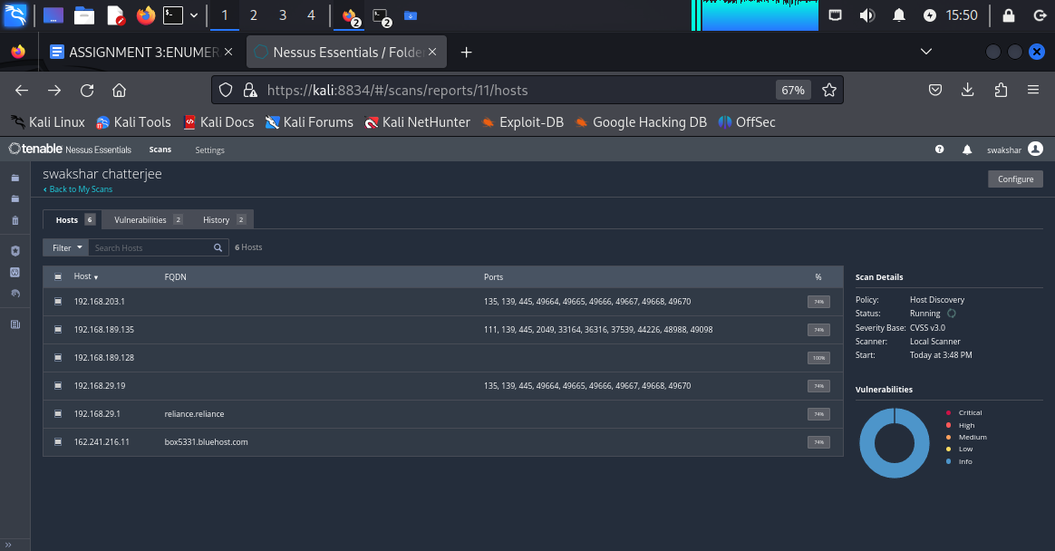

**These are the list of open ports for the respective**

**Destination ip addresses.**

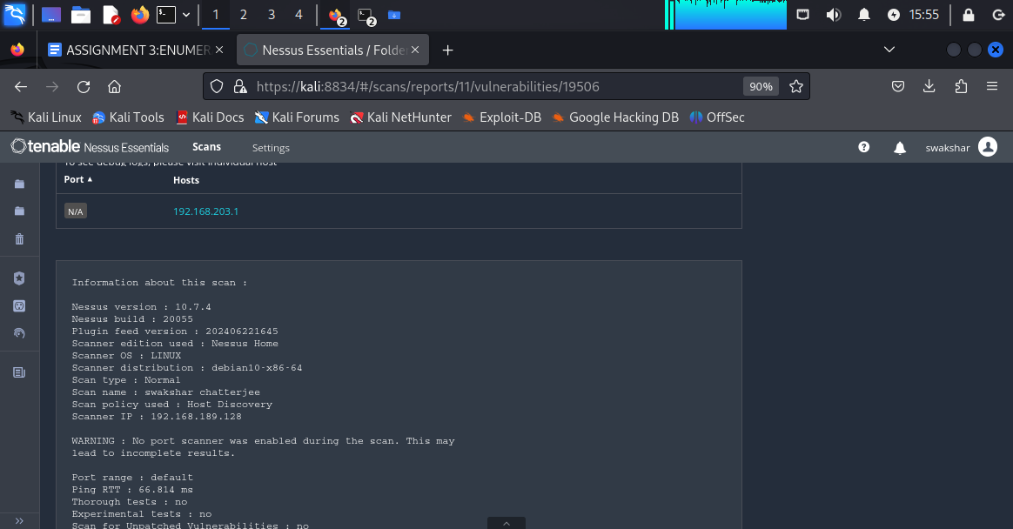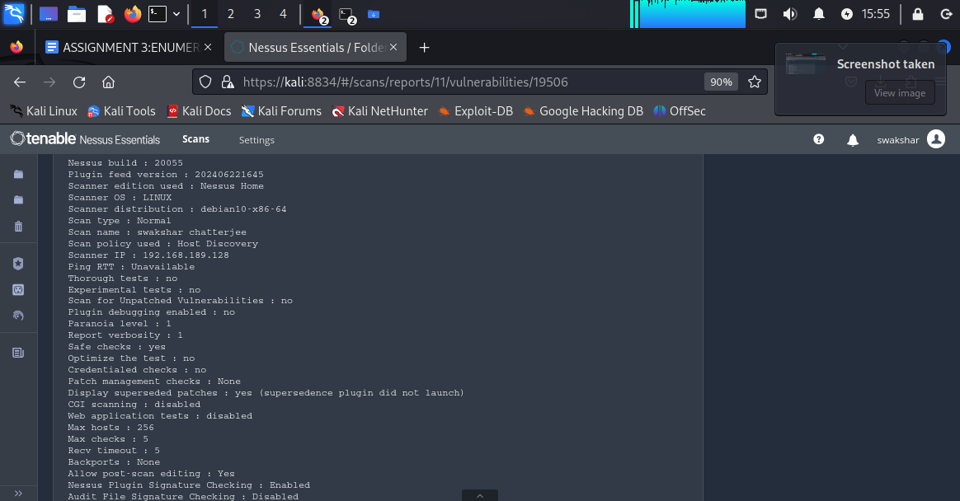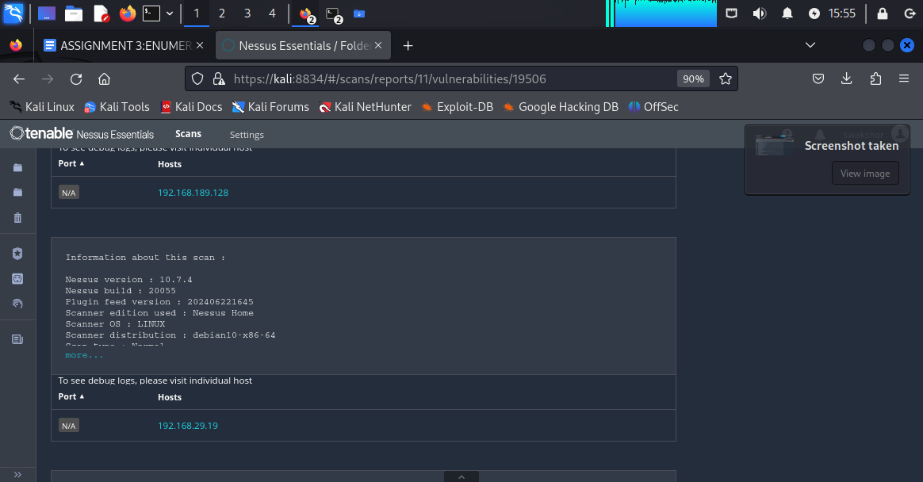

**INFORMATION ABOUT THE HOST DISCOVERY REPORT.**

**BASIC HOST DISCOVERY REPORT FOR THE METASPLOITABLE 2 DEVICE:**

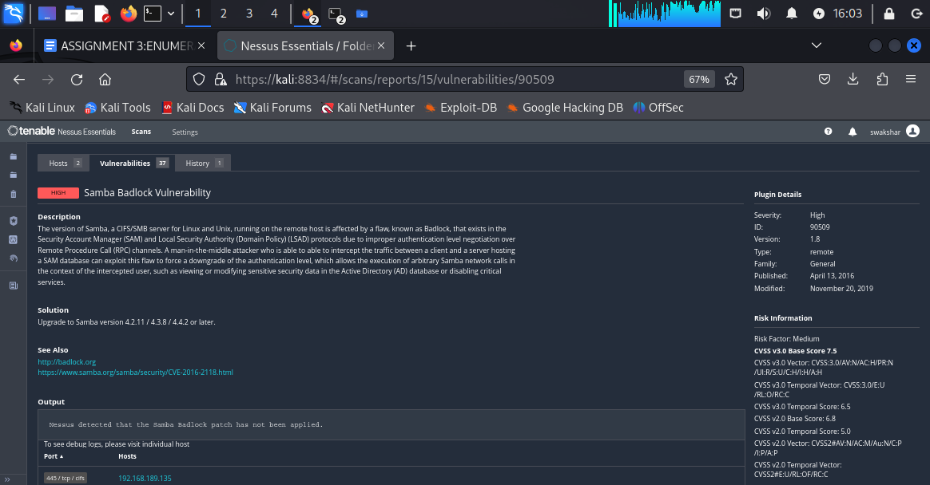

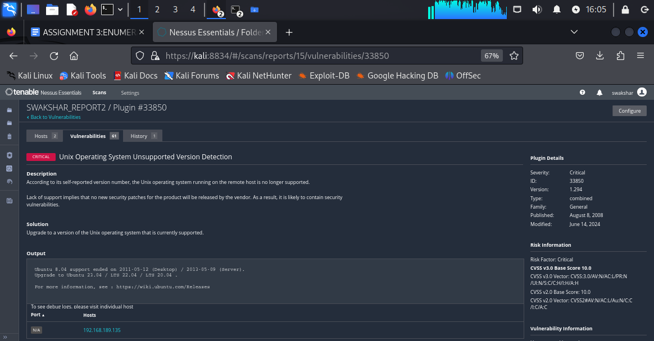

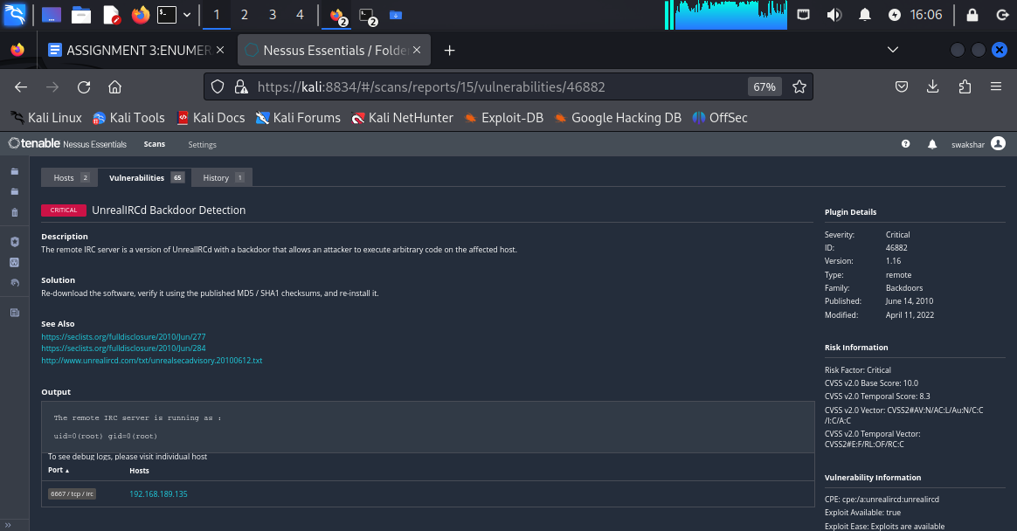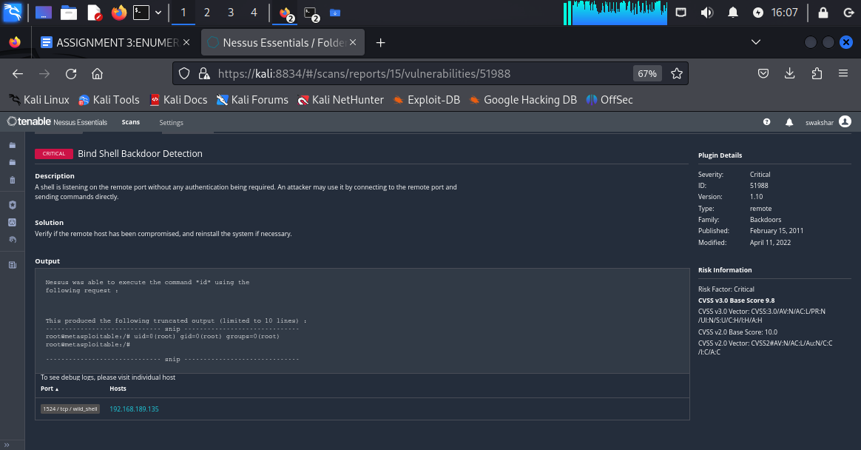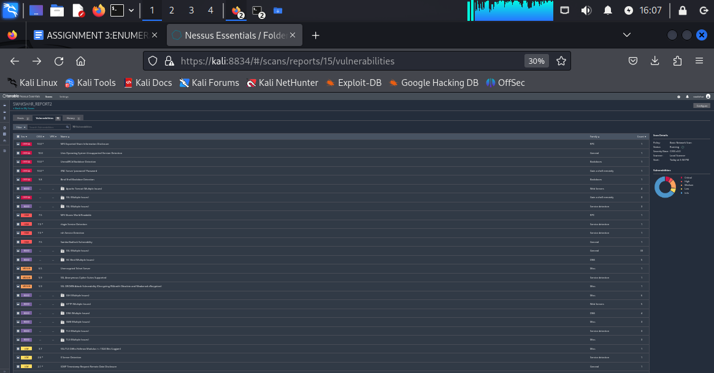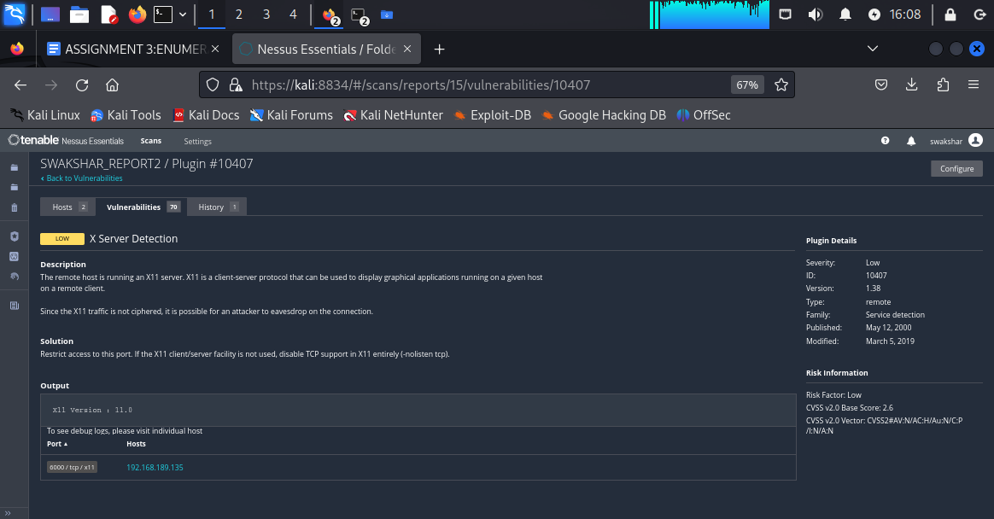

**These are the screenshots of the vulnerabilities found by “NESSUS”**

**ADDITIONAL INFORMATION:**

**We can also use OPENVAS in order to find website/target vulnerabilities:**

**Here are all the steps required:**

**1. Sudo apt install openvas**

**2.sudo apt install gvm**

**3.gvm-feed-update**

**4.gvm-setup**

**5.gvm-check-setup**

**NOW AUTOMATICALLY IT WILL GIVE YOU A URL ALONG WITH A PORT NUMBER WHICH IS**

**127.0.0.1:9392 AND IT WILL INFORM YOU TO LOG IN TO THE GREENBONE WEBSITE.**

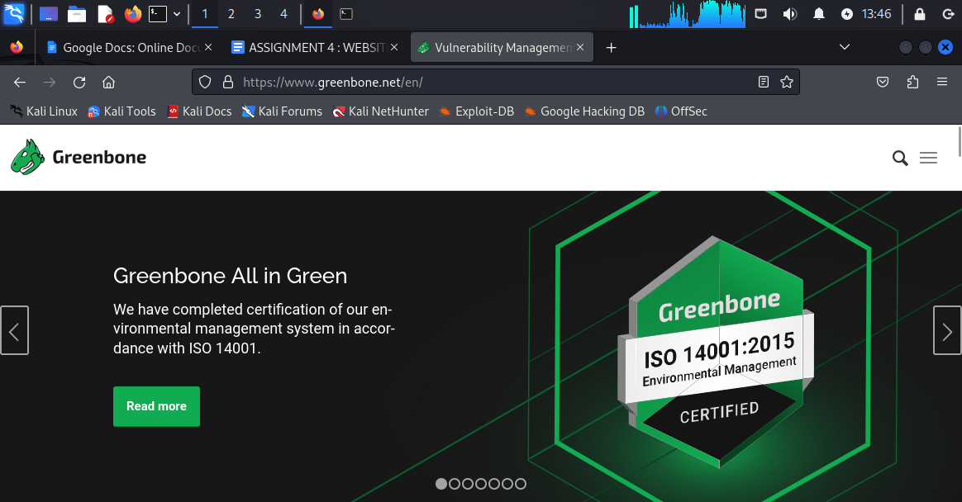

**Here after login with the right credentials we will be**

**Going to tasks>>new task or scan>>then put the target ip address and we will get the desired result.OPENVAS is quite similar to NESSUS in terms**

**of exposing detailed vulnerabilities .**

**\*\*\*\*\*\*\*\*\*\*end of assignment\*\*\*\*\*\*\*\*\*\*\*\*\*\*\*\*\*\*\*\*\***